**DEPARTMENT OF MINING AND MINERAL ENGINEERING**

**THE UNIVERSITY OF BAMENDA**

**NATIONAL HIGHER POLYTECHNIC INSTITUTE**



**REAL-TIME MONITORING SYSTEM FOR OPERATIONAL COORDINATION, TRACKING, AND PREDICTIVE MAINTENANCE AT CARRIÈRE MODERNE QUARRY, NKOLOMAN–YAOUNDÉ**

A Project Submitted to the Department of Mining and Mineral Engineering in the National Higher Polytechnic Institute of The University of Bamenda in Partial Fulfillment of the Requirements for the Award of a Master’s of Engineering (M.Eng) in Mining and Mineral Engineering

BY:

**JAM RANSOM**

**(B.Eng)**

**UBa24EP187**

Field-SUPERVISOR

**ENGR. MBOHOU ABOUBAKAR**

(Blasting Engineer)

SUPERVISOR

**Dr. AYE ANEHUMBU BEYANU**

(PhD)

CO-SUPERVISOR

**Dr. ATEH KEVIN IJUNGI**

(PhD)

**October, 2025**

ABSTRACT

Small-scale quarry operations often rely on manual reporting and reactive maintenance, leading to inefficient workflows, unplanned equipment downtime, and inconsistent production tracking. This study presents the design, implementation, and evaluation of an integrated, real-time data-driven framework at Carrière Moderne, Yaoundé. Leveraging bespoke KoboToolbox digital forms, field data across drilling, blasting, crushing, maintenance, and supervisory activities were captured and automatically synchronized into a centralized Google Sheets and BigQuery repository via Google Apps Script. A multi-page Looker Studio dashboard provided near–real-time visualization of drilling performance, production volumes, maintenance activities, and safety incidents, with interactive filters for shift and location drill-down. Predictive analytics models, built and deployed using BigQuery ML, utilized rolling-window and lagged features to forecast equipment breakdowns, achieving an AUC-ROC of 0.85 and recall above 0.70 at 80% precision. Impact evaluation, combining pre-post KPI comparisons, user surveys, and operational observations, demonstrated substantial reductions in unplanned downtime and improved maintenance scheduling. The framework’s modular architecture, cloud-native scalability, and user-driven design offer a replicable blueprint for enhancing productivity, equipment reliability, and decision-making in similar resource-constrained mining environments.

Keywords: Real-time monitoring, Quarry Operations, Digital data capture, Predictive maintenance, Machine Learning

RÉSUME

Les exploitations de carrières à petite échelle reposent souvent sur des rapports manuels et une maintenance réactive, ce qui entraîne des processus inefficaces, des arrêts non planifiés et un suivi de production inconsist ant. Cette étude présente la conception, la mise en œuvre et l’évaluation d’un cadre intégré et piloté par les données en temps réel à Carrière Moderne, Yaoundé. S’appuyant sur des formulaires numériques personnalisés KoboToolbox, les données de terrain relatives au forage, au dynamitage, au concassage, à la maintenance et à la supervision ont été collectées et synchronisées automatiquement dans un référentiel centralisé Google Sheets et BigQuery via Google Apps Script. Un tableau de bord multipage Looker Studio offre une visualisation quasi instantanée des performances de forage, des volumes de production, des activités de maintenance et des incidents de sécurité, avec des filtres interactifs pour affiner par équipe ou zone d’exploitation. Des modèles d’analyse prédictive, développés et déployés avec BigQuery ML, utilisent des fenêtres glissantes et des variables décalées pour anticiper les pannes d’équipement, atteignant une AUC-ROC de 0,85 et un rappel supérieur à 0,70 pour 80 % de précision. L’évaluation d’impact, combinant comparaisons d’indicateurs avant/après, enquêtes auprès des utilisateurs et observations opérationnelles, a démontré une réduction significative des arrêts non planifiés et une amélioration de la planification de la maintenance. L’architecture modulaire, l’évolutivité native cloud et le design centré utilisateur de ce cadre constituent un modèle reproductible pour améliorer la productivité, la fiabilité des équipements et la prise de décision dans des environnements miniers aux ressources limitées.

Mots-clés : surveillance en temps réel, opérations de carrière, capture de données numériques, maintenance prédictive, apprentissage automatique

DEDICATION

This piece of work is dedicated to my mother NSOM COMFORT FUAM

ACKNOWLEDGMENT

I am very grateful to my supervisor, Dr. Aye Aneihumbu Beyenu (PhD), for her guidance and support throughout this research. I also thank my co-supervisor, Dr. Ateh Kevin Ijungi (PhD), for his helpful advice.

Thank you to all the staff in the Department of Mining and Mineral Engineering for their help with data collection and field work. I am also grateful to the management of Carrière Moderne for providing resources and support for the real-time monitoring system.

I appreciate my classmates for their friendship, discussions, and support, which made this work better.

I also thank the administrative and technical staff for their work behind the scenes that kept everything running smoothly. I am especially thankful to my family and friends for their encouragement and patience. Finally, I thank all other colleagues, partners, and well-wishers for their interest and help in completing this project.

TABLE OF CONTENTS

ABSTRACT i

RÉSUME ii

DEDICATION iii

ACKNOWLEDGMENT iv

LISTS OF FIGURES viii

LIST OF ABBREVIATIONS ix

CHAPTER 1: INTRODUCTION 1

1.1 Background of the Study 1

1.2 Problem Statement 2

1.3 Research Questions 3

1.3.1 Main research question 3

1.3.2 Specific research questions 3

1.4 Objectives 3

1.4.1 Overall objective 3

1.4.2 Specific objectives 3

1.5 Scope of the Study 4

1.6: Location of study area 4

CHAPTER TWO: LITERATURE REVIEW 5

2.1 Real-time Data Systems in Surface Mining 5

2.2 Digital Data-entry Platforms for Field Crews 6

2.2 Digital Data-entry Platforms for Field Crews 7

2.3 Production-tracking Dashboards and Key Performance Indicators 8

2.4 Predictive Maintenance Techniques in Mining 9

2.5 Research Gaps 10

CHAPTER 3: MATERIALS AND METHODS 11

3.1 Materials 11

3.1.1 Digital Data Collection Instruments 11

3.1.2 Central Data Repositories 11

3.1.3 Processing and Analytics Tools 11

3.1.4 Visualization Platform 12

3.1.5 Supporting Infrastructure 12

3.2 Methods 12

3.2.1 Field Methods 12

3.2.2 Processing Methods 12

3.2.3 Creation of the Data Collection Instruments 13

3.3 Data Synchronisation and Management 19

3.3.1 Incremental minute Synchronization 19

3.3.4 Error Handling and System Monitoring 19

3.3.5 Dynamic Schema Management and Data Quality Control 19

3.4 Predictive Analytics Model for Equipment Breakdowns 19

3.4.1 Data Preparation and Feature Engineering 20

3.4.2 Model Selection and Training 20

3.4.3 Model Validation and Deployment 20

3.4.4 Continuous Monitoring and Model Refinement 20

3.5 Impact Evaluation 20

3.5.1 Pre- and Post-Implementation Comparison 21

3.5.2 Field Observations and Workflow Mapping 21

3.5.3 User Feedback and Perception Surveys 21

3.5.4 Continuous Feedback and Improvement Loop 21

CHAPTER 4: RESULTS AND DISCUSSIONS 22

4.1 RESULTS 22

4.1.2 Deployment of the Digital Data-Entry Platform for All Forms (Objective 1) 22

4.1.2.1 Drill Hole Details 22

4.1.2.2 Drilling Operations 23

4.1.2.3 Post_Blast 26

4.1.2.4 Processing Operations 28

4.1.2.5 Maintenance_Log 30

4.2.6 Blasting_Team 32

4.1.2.7 Supervisor_Log 34

4.1.3 Real-Time Operations and Production-Tracking (Objective 2) 36

Overview and Functionality 36

4.1.4 Development and Validation of Predictive Analytics Models 41

4.1.5 Impact Evaluation on Workflow Efficiency and Downtime 44

4.2 DISCUSSION 47

4.2.1 Innovation in Digital Data Capture 47

4.2.2 Innovation in Real-Time Monitoring and Decision Support 48

CHAPTER 5: CONCLUSIONS AND RECOMMENDATIONS 49

CONCLUSION 49

RECOMMENDATIONS 49

REFERENCES 51

APPEDIX 55

LISTS OF FIGURES

Figure 1.1: Location map of Carriere Moderne 4

Figure 4.1: Screenshot of the active Drill_Hole_Detail form on mobile. 23

Figure 4.2: Partial sheet view showing consecutive daily holes details in the central database 23

Figure 4.3. Drill_Operator form screenshot. 24

Figure 4.4: Sample entries showing operators data on the central database 25

Figure 4.5: Screenshot of the Post_Blast form. 26

Figure 4.6: Entries illustrating blast assessment data. 27

Figure 4.7: Processing operations form screenshot. 28

Figure 4.8: Processing operations records. 29

Figure 4.9: Maintenance_Log form screenshot. 30

Figure 4.10: Maintenance activity 31

Figure 4.11: Blasting_Team form screenshot. 32

Figure 4.12: Blasting team records detailing design parameters. 33

Figure 4.13: Supervisor_Log form screenshot. 34

Figure 4.14: Supervisor shift summaries capturing qualitative insights. 35

Fig 4.15: Quick overview of operations 36

Fig 4.16: Production tracking dashboard 37

Fig 4.17: Drilling operations dashboard 38

Fig 4.18: Blasting operations dashboard 39

Fig 4.19: Maintenance activity dashboard 40

Fig 4.20 Production Summary 41

LIST OF ABBREVIATIONS

|  |  |
| --- | --- |
| API | Application Programming Interface |
| ERP | Enterprise Resource Planning |
| GIS | Geographic Information System |
| KPI | Key Performance Indicator |
| ML | Machine Learning |
| NAHPI | National Higher Polytechnic Institute |
| UUID | Universally Unique Identifier |
| UX | User Experience |
| UI | User Interface |

CHAPTER 1: INTRODUCTION

1.1 Background of the Study

Surface mining, particularly quarrying, represents a critical component in supplying the global construction sector with essential raw materials, including aggregates such as sand, gravel, and crushed stone. Efficient quarry operations are fundamental for ensuring steady supply chains and supporting economic development (World Economic Forum, 2020). Over recent decades, substantial technological advancements have enabled large-scale mining operations to adopt sophisticated real-time data systems, significantly improving operational efficiency, safety standards, and productivity (Zhou et al., 2018).

Real-time data systems integrate various technological elements, including IoT sensors, telematics, and wireless networks, enabling immediate monitoring and management of equipment performance, production metrics, and environmental conditions (Kumar et al., 2019). These advanced systems facilitate rapid decision-making and provide managers with instantaneous information, allowing swift reactions to operational changes or anomalies. The implementation of these technologies has resulted in tangible improvements, such as reduced downtime, enhanced equipment utilisation, improved safety conditions, and better compliance with environmental regulations (World Economic Forum, 2020).

Despite these advances, small- to medium-scale quarry operations, particularly in developing regions such as Cameroon, often continue to rely heavily on traditional, manual methods of data collection and reporting. Field data in these smaller quarries, including vital operational parameters like drilling specifics, blasting outcomes, and equipment status, are frequently recorded on paper or communicated verbally. This manual handling results in substantial delays, data inaccuracies, and reactive maintenance practices rather than proactive strategies (Ndzana et al., 2021).

The persistent reliance on outdated methods at Carrière Moderne, situated in Yaoundé, exemplifies these operational inefficiencies. Data collected by engineers, drill operators, and maintenance crews remain inaccessible in real-time, severely limiting the ability to monitor operational activities effectively, anticipate equipment failures, and optimise production processes. The resultant operational delays, increased equipment downtime, and reduced productivity highlight the urgent necessity for implementing digital, real-time data systems designed specifically to meet the operational and resource constraints of smaller quarry operations.

Recognising these limitations and operational gaps, this research focuses on developing an integrated real-time data-driven framework tailored explicitly to the operational realities faced by Carrière Moderne. This study aims to leverage existing technological advancements adapted to the unique conditions of smaller-scale quarry operations, ensuring enhanced collaboration among field personnel, timely predictive maintenance interventions, and effective real-time tracking of production volumes. Addressing these specific operational challenges through targeted research can substantially improve operational effectiveness and contribute to broader adoption of digital technologies within the mining sector in developing regions (Tambo et al., 2022).1.2 Rationale

Implementing a real-time data-driven system addresses the existing gaps in communication and operational efficiency at Carrière Moderne. The adoption of digital data-entry platforms, predictive analytics for maintenance scheduling, and real-time production tracking dashboards will significantly reduce unplanned downtime and enhance overall operational efficiency. Such a system will facilitate timely and informed decision-making, improve the lifespan of quarry equipment, and ensure more reliable production processes, ultimately enhancing the productivity and competitiveness of Carrière Moderne.

1.2 Problem Statement

Carrière Moderne quarry at Nkoloman–Yaoundé currently relies on paper-based reporting and informal verbal handovers to capture critical operational data, drilling performance, blasting outcomes, crusher throughput, maintenance activities and supervisory observations. This fragmented approach introduces significant delays, transcription errors and data inconsistencies, undermining timely decision-making, predictive maintenance scheduling and accurate production tracking. Consequently, equipment failures often occur without warning, unplanned downtime increases operational costs, and actual production volumes cannot be reliably compared against forecasts. Without an integrated, real-time data platform, cross-functional coordination remains reactive rather than proactive, limiting the quarry’s ability to optimize resource utilization, minimize disruptions and sustain competitive performance in a demanding market.

1.3 Research Questions

1.3.1 Main research question

How can real-time monitory system enhance collaboration, reduce equipment failures, and enable real-time production tracking at Carrière Moderne?

1.3.2 Specific research questions

1. What features of a digital data-entry platform best support timely and accurate information sharing among engineers, drill operators, and maintenance personnel?

2. How can actual and forecasted production volumes be tracked in real time?

3. How can predictive analytics applied to field-collected data anticipate equipment breakdowns before they occur?

4. In what ways does real-time monitoring and predictive insight improve workflow efficiency and reduce unplanned downtime?

1.4 Objectives

1.4.1 Overall objective

The overall objective of this study was to design and implement an integrated real-time data-driven framework that enhances collaboration, reduces equipment failures, and enables continuous real-time production tracking at Carrière Moderne.

1.4.2 Specific objectives

1. To identify and integrate features into a digital data-entry platform to enhance timely and accurate information sharing among field crews and engineers.

2. To establish a real-time production-tracking dashboard for monitoring actual and forecasted production volumes.

3. To develop and validate predictive analytics models for anticipating equipment breakdowns using field-collected data.

4. To evaluate how real-time monitoring and predictive insights impact workflow efficiency and operational downtime.

1.5 Scope of the Study

This study is confined to designing, implementing, and evaluating a cloud-native, real-time monitoring framework for Carrière Moderne quarry in Nkoloman–Yaoundé. It encompasses the creation and deployment of seven KoboToolbox forms to capture drilling, blasting, crushing, maintenance, and supervisory data; automated synchronization of submissions into Google Sheets and BigQuery via hourly and nightly scripts; development of a multi-page Looker Studio dashboard to visualize production volumes, equipment performance, maintenance activities, and safety metrics; and the application of BigQuery ML models for daily forecasting of equipment breakdown risks. The framework’s uptake and impact are assessed through pre-post KPI comparisons, user surveys, and field observations over a four-month period. Excluded are IoT sensor integration, advanced geospatial analyses, and detailed financial cost–benefit evaluations.

1.6: Location of study area

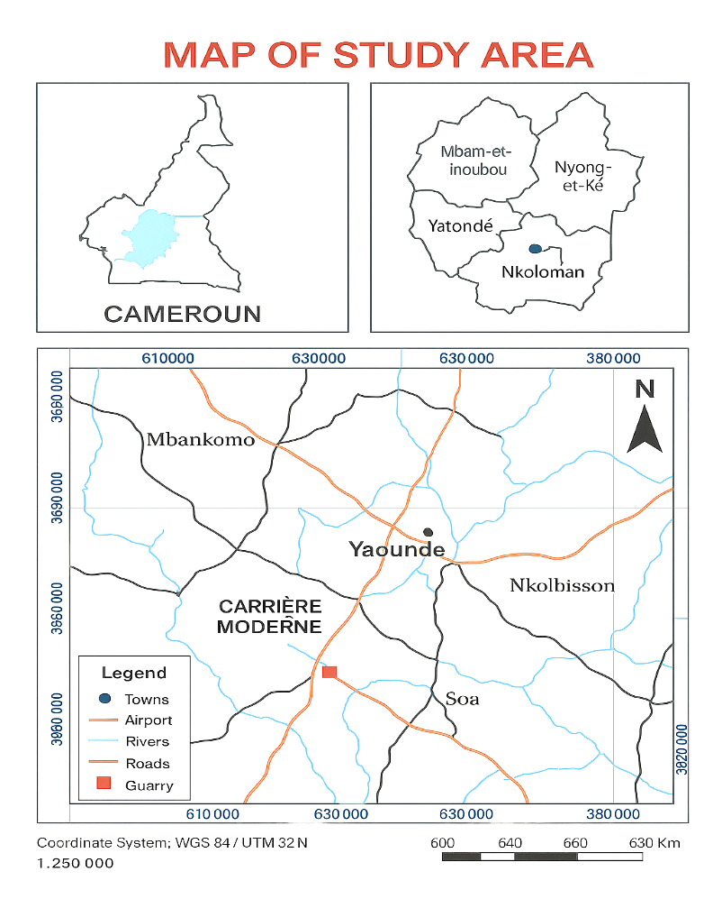

Quarry

Quarry

Figure 1.1: Location map of Carriere Moderne

CHAPTER 2: LITERATURE REVIEW

2.1 Real-time Data Systems in Surface Mining

Real-time data systems are indispensable for modern surface mining operations, offering continuous visibility into machinery health, production metrics and environmental conditions. These systems comprise the following components, each playing a critical role in ensuring efficient, safe and compliant quarrying activities:

Edge IoT Sensors and Data Acquisition Units

IoT sensors mounted on drill rigs, haul trucks, crushers and conveyors capture high-frequency data, including vibration, temperature, pressure, throughput and fuel consumption, at the point of operation (Zhou et al., 2018). Data acquisition units located at the edge preprocess this raw data, applying initial filtering and event detection to minimise bandwidth usage and transmit only aggregated summaries or critical alerts to central systems (Kumar et al., 2019).

Wireless Communication and Networking

Captured data are transmitted via a resilient mix of cellular (4G/5G), satellite and local mesh networks. This hybrid approach mitigates the challenges of intermittent coverage in remote quarry sites by providing multiple data pathways, thereby reducing latency and enhancing system reliability (Ndzana et al., 2021).

Centralised Analytics and Dashboard Platforms

Cloud-based analytics platforms consolidate incoming data streams and apply machine learning algorithms to detect anomalies and forecast equipment degradation. Models trained on historical breakdown records and live sensor feeds can identify early warning signs of failure, enabling maintenance to be scheduled during planned downtime and reducing unplanned stoppages by up to 30% (Patel et al., 2019; World Economic Forum, 2020). Interactive dashboards visualise key performance indicators, such as active rig count, average cycle times, downtime incidents and environmental metrics, through desktop and mobile interfaces for engineers and site managers.

Operational Benefits

Real-time data systems deliver several key advantages to surface mining operations. First, early detection of equipment faults allows maintenance teams to intervene promptly, resulting in significant reductions in downtime and improvements in overall equipment effectiveness. Second, continuous monitoring of environmental parameters, such as dust levels, noise emissions and air quality, ensures adherence to occupational health and environmental regulations, thereby enhancing site safety and compliance. Third, data-driven insights enable managers to make rapid adjustments to drilling patterns, haulage routes and crusher settings, optimising throughput and resource allocation across the quarry.

Challenges for Smaller Operations

Despite clear benefits, small- to medium-scale quarries often encounter barriers to implementation, namely high upfront costs, limited technical expertise and intermittent connectivity (Tambo et al., 2022). Emerging solutions such as modular sensor kits (CFA 300,000 per node), low-code dashboard builders and enhanced edge analytics features offer more accessible entry points, facilitating adoption even in resource-constrained settings.

2.1.1 Implementation Challenges in Resource-Constrained Environments

While the operational benefits of real-time data systems are well-documented for large-scale mines, their implementation in small-to-medium-scale quarries, particularly in developing regions, presents a unique set of challenges that extend beyond simple technical adoption. These constraints significantly influence the design and feasibility of technological solutions.

Financial Barriers: The capital expenditure required for high-fidelity IoT sensors, robust communication infrastructure, and proprietary enterprise software is often prohibitive for smaller operations (Tambo et al., 2022). The return on investment (ROI) calculation differs markedly; where a large mine can justify multi-million-dollar expenditures for incremental gains, a small quarry requires low-cost, high-impact solutions. This necessitates a focus on leveraging existing, affordable consumer-grade technology and open-source or low-code platforms, as demonstrated by the use of KoboToolbox and Google Cloud services in this study.

Technical Expertise and Human Capacity: Small quarries typically lack dedicated IT staff or data scientists. The in-house expertise resides in practical mining and mechanical engineering. Therefore, any proposed system must be operable and maintainable by existing personnel with minimal training. This "skills gap" creates a reliance on intuitive user interfaces, reliable external platforms, and solutions that minimize the need for complex configuration or coding (Ndzana et al., 2021).

Infrastructural and Connectivity Limitations: The assumption of continuous, high-bandwidth connectivity, common in literature from developed regions, is often invalid. Many quarry sites, including Carrière Moderne, may experience intermittent cellular service or have limited access to stable power grids. This reality mandates an offline-first design philosophy, where data capture and core application logic can function independently of a network connection, with synchronization occurring as a secondary, background process when connectivity is restored (Cleverdon & Turner, 2020).

Change Management and Digital Literacy: Transitioning from paper-based, manual workflows to digital systems requires a cultural shift. Field crews accustomed to clipboards and verbal reports may resist new technology due to discomfort, fear of being monitored, or a lack of digital literacy. Successful implementation is therefore not merely a technical deployment but an organizational change process that requires stakeholder engagement, participatory design, and continuous support (Davis et al., 1989; Venkatesh et al., 2003).

Addressing these multifaceted challenges is not an optional enhancement but a fundamental requirement for any system intended for this context. The framework developed in this research was designed with these very constraints as primary design parameters.

2.2 Digital Data-entry Platforms for Field Crews

Digital data-entry platforms have transformed data collection processes in industries ranging from agriculture to healthcare and mining, delivering marked improvements in data accuracy and reporting efficiency (Tambo et al., 2022). In the context of quarry operations, these platforms enable engineers, drill operators and maintenance personnel to record drilling parameters, blasting results and equipment performance directly on mobile devices. Such direct entry eliminates manual transcription steps, reducing the incidence of human error and accelerating data availability for analysis (Patel et al., 2019).

Critical features that support successful deployment include intuitive user interfaces designed for minimal training requirements, offline data storage capabilities to accommodate intermittent connectivity in remote quarry sites and automated validation routines that flag inconsistent or out-of-range entries in real time (Ndzana et al., 2021). Platforms such as KoboToolbox, Microsoft Forms and bespoke low-code applications have demonstrated the capacity to synchronise collected data with centralised databases upon network restoration, ensuring seamless integration into analytics workflows (Patel et al., 2019).

User-centred design approaches, involving iterative feedback from field crews during the development phase, have proven essential for achieving high adoption rates and data quality (Tambo et al., 2022). Field studies indicate that when operators are engaged in form design, selecting relevant fields, default values and dropdown options, the completeness and reliability of submitted data improve significantly, reaching accuracy levels above 95 per cent in some deployments (Patel et al., 2019).

By enabling near-immediate access to operational data, digital data-entry platforms empower site managers to monitor daily drilling progress, assess blast efficiency and track maintenance actions without the traditional delays associated with paper-based reporting. Consequently, decision-making cycles become shorter, allowing for more proactive intervention and enhanced coordination among multidisciplinary teams.

2.2 Digital Data-entry Platforms for Field Crews

Digital data-entry platforms have transformed data collection processes in industries ranging from agriculture to healthcare and mining, delivering marked improvements in data accuracy and reporting efficiency (Tambo et al., 2022). In the context of quarry operations, these platforms enable engineers, drill operators and maintenance personnel to record drilling parameters, blasting results and equipment performance directly on mobile devices. Such direct entry eliminates manual transcription steps, reducing the incidence of human error and accelerating data availability for analysis (Patel et al., 2019).

Critical features that support successful deployment include intuitive user interfaces designed for minimal training requirements, offline data storage capabilities to accommodate intermittent connectivity in remote quarry sites and automated validation routines that flag inconsistent or out-of-range entries in real time (Ndzana et al., 2021). Platforms such as KoboToolbox, Microsoft Forms and bespoke low-code applications have demonstrated the capacity to synchronise collected data with centralised databases upon network restoration, ensuring seamless integration into analytics workflows (Patel et al., 2019).

User-centred design approaches, involving iterative feedback from field crews during the development phase, have proven essential for achieving high adoption rates and data quality (Tambo et al., 2022). Field studies indicate that when operators are engaged in form design, selecting relevant fields, default values and dropdown options, the completeness and reliability of submitted data improve significantly, reaching accuracy levels above 95 per cent in some deployments (Patel et al., 2019).

By enabling near-immediate access to operational data, digital data-entry platforms empower site managers to monitor daily drilling progress, assess blast efficiency and track maintenance actions without the traditional delays associated with paper-based reporting. Consequently, decision-making cycles become shorter, allowing for more proactive intervention and enhanced coordination among multidisciplinary teams.

2.3 Production-tracking Dashboards and Key Performance Indicators

Production-tracking dashboards have become instrumental in modern mining operations by translating complex operational data into clear visual insights. These dashboards draw upon real-time feeds from field sensors and digital entry platforms to display key performance indicators, including daily output tonnage, equipment utilisation rates, cycle times and unscheduled downtime incidents (World Economic Forum, 2020). By consolidating these metrics into interactive charts and tables accessible via desktop and mobile interfaces, dashboards enable managers to quickly identify performance variances and operational bottlenecks.

Effective dashboards in quarry contexts typically feature visualisations such as time-series graphs for production trends, heat maps for equipment performance across different shifts and gauges indicating utilisation percentages. Studies indicate that visual emphasis on critical KPIs improves situational awareness, allowing teams to detect declines in throughput or spikes in downtime within minutes of occurrence (Patel et al., 2019). Furthermore, real-time threshold alerts, for instance, when daily production falls below a predefined target, prompt immediate investigation and corrective actions, thereby reducing lag between issue detection and resolution.

Beyond performance monitoring, production-tracking dashboards also support strategic planning by archiving historical data that can be analysed for seasonal patterns, equipment lifecycle planning and resource allocation. Over extended periods, trend analyses derived from dashboard archives inform decisions such as scheduling major maintenance during low-demand seasons, reallocating equipment between quarry zones based on performance, and forecasting material supply to downstream operations. In this way, dashboards serve not only as operational tools for daily management but also as strategic assets for medium- and long-term planning (Zhou et al., 2018).

2.4 Predictive Maintenance Techniques in Mining

Predictive maintenance represents a shift from traditional reactive approaches to a proactive strategy in mining operations, aiming to anticipate equipment failures before they occur. This technique exploits historical maintenance records and real-time data streams to model equipment health and predict degradation patterns (Kumar et al., 2019). Data sources typically include vibration signatures, temperature readings, hydraulic pressures and fuel consumption rates, all of which provide indicators of mechanical wear and impending faults (Patel et al., 2019).

Machine learning algorithms such as random forests, support vector machines and neural networks have demonstrated high accuracy in classifying equipment states and forecasting failure events. These models are trained on labeled datasets containing instances of both normal operation and known failure precursors, enabling the system to recognise early warning signs in live sensor feeds. Research has shown that implementing predictive maintenance can reduce unscheduled downtime by up to 30 per cent and decrease maintenance costs by approximately 25 per cent compared with reactive maintenance regimes (World Economic Forum, 2020).

For resource-constrained quarry operations, simplified predictive models based on routinely collected field data, such as drill counts, engine hours and maintenance logs, can still yield significant benefits. Regression-based approaches and threshold-based alerts require minimal computational resources and can be embedded within low-code analytics platforms. Field trials in similar industrial settings have demonstrated improvements in mean time between failures and overall equipment effectiveness, even when high-fidelity sensors are not available (Ndzana et al., 2021).

Successful deployment of predictive maintenance hinges on data quality, cross-functional collaboration and continuous model refinement. Engaging maintenance technicians in defining relevant failure modes and validation criteria ensures that predictive alerts are trusted and acted upon. Ongoing monitoring of model performance and periodic retraining with new failure data help maintain accuracy over changing operational conditions. In sum, predictive maintenance offers a pragmatic pathway for quarries to transition from costly breakdown interventions to efficient, planned maintenance schedules, thereby optimising equipment utilisation and extending asset lifecycles.

To contextualize the selection of predictive maintenance techniques for a resource-constrained environment, it is useful to compare the spectrum of available approaches. The evolution from reactive to predictive strategies represents a trade-off between implementation cost, complexity, and potential benefit. The following table summarizes key maintenance methodologies relevant to the mining sector.

Table 2.1: Comparison of Maintenance Strategies in Mining Operations

|  |  |  |  |  |
| --- | --- | --- | --- | --- |
| Maintenance Strategy | Core Principle | Data Requirements | Typical Tools & Techniques | Suitability for Small-Scale Quarries |
| Reactive (Run-to-Failure) | Repair equipment only after a breakdown occurs. | None (post-failure records only). | Basic tools, spare parts inventory. | High (low cost, but high downtime cost). |
| Preventive (Time-Based) | Perform maintenance at fixed time/intervals regardless of condition. | Equipment manuals, operating hours. | Scheduled work orders, CMMS*. | Medium (simple to schedule, but can lead to over-maintenance). |
| Condition-Based (CBM) | Monitor actual equipment condition to trigger maintenance. | Periodic sensor data (vibration, temperature, oil analysis). | Portable data collectors, basic sensors. | Medium-Low (requires sensor investment and analysis skills). |
| Predictive (PdM) | Forecast failures using data analytics and trends. | Historical failure data, real-time operational data. | Machine Learning, IoT platforms, advanced analytics. | Low (This study's focus) - requires historical data and analytics capability, but can be simplified. |

As illustrated in Table 2.1, Predictive Maintenance (PdM) offers the most advanced approach by aiming to anticipate failures, thereby optimizing maintenance schedules and minimizing unplanned downtime. However, its traditional implementation, reliant on costly sensor networks and specialized software, places it at a low suitability level for small-scale quarries. The innovation, therefore, lies in adapting the PdM philosophy to a low-data, low-cost environment. This study explores a simplified PdM approach, leveraging routinely collected operational data (e.g., drill times, hole counts, maintenance logs) in place of dedicated sensor streams, making predictive insights accessible within the constraints outlined in Section 2.1.1.

2.5 Data Integration and Cloud-Native Architectures for Industrial Monitoring

The value of field data is fully realized only when it is integrated, accessible, and actionable. Modern real-time monitoring systems rely on robust data pipelines that move information from the point of collection to the point of decision-making. For small-scale operations, cloud-native architectures offer a paradigm shift by providing enterprise-grade capabilities without the need for significant on-premise hardware investment.

The data pipeline typically follows an ETL (Extract, Transform, Load) or ELT (Extract, Load, Transform) process. In this context, Extraction involves pulling data from source systems, such as the KoboToolbox API. Transformation encompasses cleaning, validating, and engineering features from the raw data to make it suitable for analysis, a critical step for preparing data for predictive models. Loading is the process of inserting this processed data into a central repository, such as a cloud data warehouse like Google BigQuery (Alwan & Yusof, 2020).

The role of APIs (Application Programming Interfaces) is pivotal in this architecture. They act as standardized intermediaries that allow different software applications (e.g., KoboToolbox, Google Apps Script, BigQuery) to communicate and share data seamlessly (Ismail & Ahmad, 2021). This interoperability is key to building a modular system where best-of-breed tools can be combined, as demonstrated in this study's use of KoboToolbox for collection, Google Sheets for interim storage, and BigQuery for advanced analytics.

Cloud data warehouses like BigQuery represent a cornerstone of this approach. They offer serverless, scalable storage and immense computational power on demand, eliminating the need for manual database administration and hardware provisioning (White & Kumar, 2019). This is particularly advantageous for small operations, as it converts capital expenditure into a manageable operational cost that scales with usage. Furthermore, the integration of machine learning capabilities directly within the data warehouse, such as BigQuery ML, dramatically lowers the barrier to entry for advanced analytics by allowing models to be built and deployed using simple SQL syntax, bypassing the need for separate, complex data science environments.

This cloud-native, API-driven architecture provides the technical foundation for the real-time monitoring framework developed in this research, enabling a level of sophistication in data processing and analytics that was previously inaccessible to quarries of this scale.

2.5 Research Gaps

Although significant progress has been made in deploying real-time data systems, digital data-entry platforms and predictive maintenance techniques within large-scale mining contexts, notable gaps remain regarding their applicability and adaptation to small- and medium-scale quarry operations in developing regions. First, most existing studies focus on enterprises with extensive financial and technical resources, limiting insight into cost‑effective architectures tailored to constrained budgets and minimal in‑house expertise (Zhou et al., 2018; Kumar et al., 2019). Second, the majority of literature assumes continuous high‑bandwidth connectivity, whereas many quarries in regions like Cameroon face intermittent or low‑quality network access, necessitating offline‑capable solutions and resilient data synchronisation strategies (Ndzana et al., 2021).

Third, little research addresses user adoption factors in environments where field personnel may have limited digital literacy. Although user‑centred design principles are acknowledged as beneficial, empirical studies evaluating long‑term acceptance, training requirements and change‑management processes in small quarries are scarce (Tambo et al., 2022; Patel et al., 2019). Fourth, integration of production‑tracking dashboards with predictive maintenance modules within a unified, low‑code framework has not been extensively explored, leaving unclear how combined systems perform under real‑world constraints and diverse operational scenarios.

Finally, while simplified predictive models based on basic field data have shown promise in resource‑constrained industrial settings, their validation and comparative performance against sensor‑rich approaches require further investigation. Addressing these research gaps through targeted field trials and co‑design methodologies will be critical for developing pragmatic, scalable solutions that deliver measurable improvements in collaboration, equipment reliability and real‑time production tracking at quarries such as Carrière Moderne.

3.3.2 Consolidated Data Fetching Script for Initialization

During the development and initial deployment phase of the monitoring system, a foundational Google Apps Script function, fetch_Forms_SideBySide_Corrected(), was created. This script served a critical role in establishing the central data repository and validating the data pipeline. Its primary purpose was to perform a one-time, bulk fetch of all historical submissions from each KoboToolbox form and present them in a consolidated view within a single Google Sheet named "Smart_Quarry".

The script's logic can be broken down into several key stages:

Initialization and Sheet Setup:

The function begins by defining the target sheet name and the KoboToolbox API authorization key. It then retrieves or creates the "Smart_Quarry" sheet, ensuring a clean workspace by clearing any existing content.



Form Configuration Array:

The core of the script is a JavaScript array (formConfigs) that acts as a configuration manifest. Each object in this array defines a specific KoboToolbox form to be polled. The configuration for a form includes:

id: The unique asset ID of the form on the KoboToolbox server.

label: A human-readable name for the form (e.g., "Drill_Operator").

fields: An explicit list of the specific data fields to be extracted from each form submission. This includes both system metadata like _submission_time and the custom fields defined in the form (e.g., drill_info/entry_by, drill_info/holes_drilled). This selective field extraction is crucial for managing data complexity and focusing on relevant information.

Data Retrieval and Processing Loop:

The script iterates over each form configuration in the formConfigs array. For each form, it constructs the specific API endpoint URL and uses the UrlFetchApp service to make an authenticated GET request to KoboToolbox. The API responds with a JSON object containing all submission data for that form.

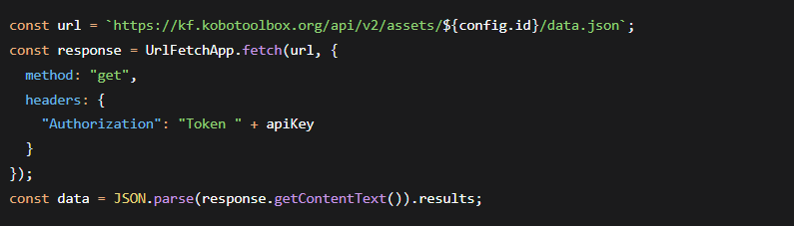

Structured Data Writing to Sheet:

For each form, the script writes a dedicated block of data into the Google Sheet. The process for each block is:

Headers: The first row of the block is populated with the column headers, which are a combination of "Source_Form" (to identify the data origin) and the list of configured fields.

Data Rows: The script maps through each form submission (record) and creates an array for each row. The row array is built by placing the form's label first, followed by the values for each specified field. This ensures every data point is explicitly linked to its source form.

Placement: Each form's data block is written to the sheet with a two-column gap (columnOffset += headers.length + 2) between it and the next block, preventing visual overlap and making the consolidated view readable.



Purpose and Utility in the Research Context:

While the primary data synchronization was handled by the incremental, near-real-time scripts described in Section 3.3.1, the fetch_Forms_SideBySide_Corrected() script was indispensable for:

System Initialization: Rapidly populating the central database with all historical data at the project's outset.

Data Validation and Debugging: Providing a side-by-side, human-readable view of data from all forms, which was instrumental in verifying API connectivity, checking data integrity, and debugging form structures during development.

Archival and Reporting: Creating a static, consolidated snapshot of the entire dataset for offline analysis or archival purposes.

2.6: Safety and Environmental Monitoring Systems

Beyond production and maintenance, real-time monitoring systems play a critical role in enhancing safety and ensuring environmental compliance, two aspects of paramount importance for the sustainable operation and social license of any quarry.

Proactive Safety Management: Traditional safety management often relies on reactive incident reporting. Digital systems enable a proactive approach. Mobile forms can be used for pre-shift equipment checks, hazard identification reports, and near-miss reporting, creating a valuable dataset of leading indicators rather than lagging incident statistics (Ismail & Ahmad, 2021). When integrated into a dashboard, this data allows safety managers to identify trends, such as recurring hazards in specific bench zones, and implement targeted interventions before an incident occurs.

Environmental Compliance Monitoring: Quarries are subject to regulations concerning dust, noise, and water quality. Continuous monitoring sensors for particulate matter (PM2.5, PM10) and noise levels can be integrated into the data architecture. Real-time visualization of this data on operational dashboards ensures that managers can immediately respond to threshold breaches, for example, by activating dust suppression systems when dust levels exceed limits (Kim & Lee, 2019). This not only ensures compliance but also demonstrates a commitment to environmental stewardship to regulators and the local community.

Geospatial Context (GIS Integration): The location data captured by mobile forms (bench_zone) provides a geospatial context to all operational data. While advanced Geographic Information System (GIS) integration was beyond the scope of this study, the foundational data exists. Future work could overlay production data, blast vibrations, and safety incidents on a digital map of the quarry, revealing spatial correlations that are invisible in tabular data alone (Schroeder & Park, 2019).

CHAPTER 3: MATERIALS AND METHODS

3.1 Materials

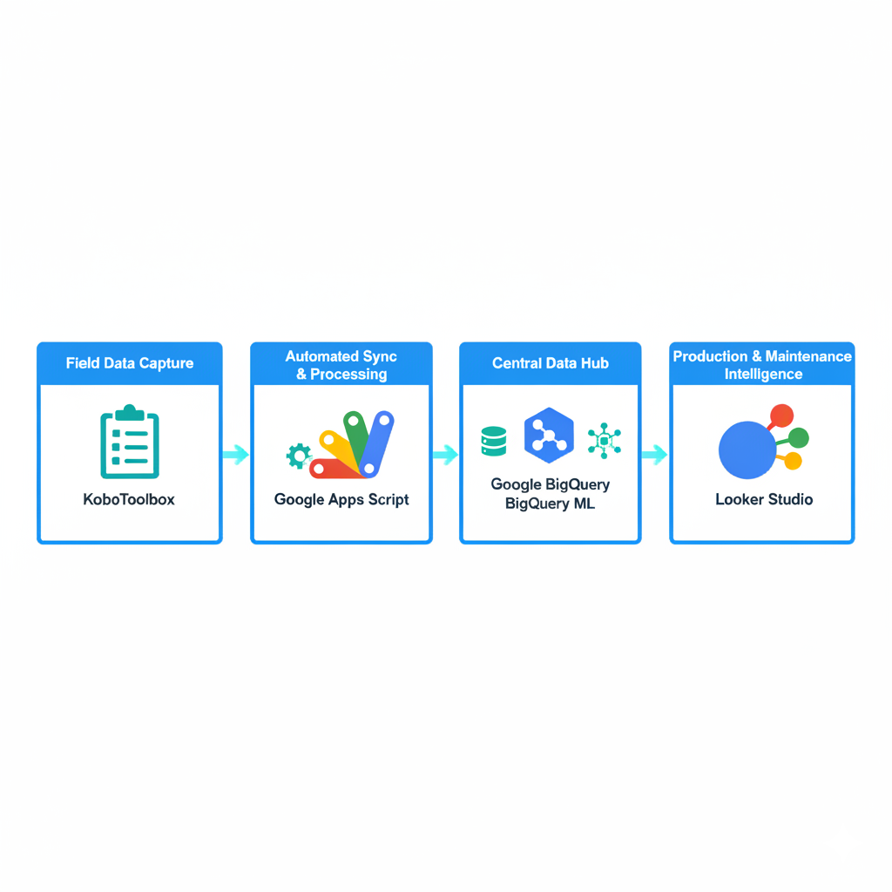

Figure 3.1: High-Level System Architecture of the Real-Time Monitoring Framework

This diagram illustrates the three-tiered, cloud-native architecture of the implemented monitoring system. The process begins with Field Data Capture via KoboToolbox forms, which is automatically synchronized and processed using Google Apps Script. The data is then centralized in a Central Data Hub comprising Google BigQuery for scalable storage and advanced analytics, and BigQuery ML for developing and deploying predictive models. The final tier, Production & Maintenance Intelligence, is delivered through interactive Looker Studio dashboards, providing operational and managerial insights for decision support.

To support the development and deployment of the real-time monitoring framework, the following materials were used:

3.1.1 Digital Data Collection Instruments

KoboToolbox Forms: Seven custom-designed forms deployed on Android tablets, corresponding to operational domains:

Drill Hole Detail (drilling parameters and whole metrics)

Drill Operator (operator performance and rig usage)

Post Blast (blast design and fragmentation data)

Crusher Operator (throughput, downtime, and product distribution)

Maintenance Log (service events, downtime, and spare-part usage)

Blasting Team (blast event details and charges)

Supervisor Log (shift summaries and safety observations)

Rationale for Technology Stack Selection

The selection of each component in the technology stack was driven by the core constraints of cost, scalability, and ease of use identified in the literature review, rather than merely their availability.

KoboToolbox: This platform was chosen over alternatives like ODK Collect or proprietary mobile forms due to its robust free tier, which accommodates a high volume of submissions, and its exceptionally user-friendly web-based form designer. This was critical for rapid, iterative form development without requiring software licensing fees.

Google Workspace & Google Cloud Platform (GCP): The integrated ecosystem of Google Sheets, Apps Script, and BigQuery provided a seamless, low-cost pipeline. Google Sheets served as a human-readable "staging area" for immediate data validation, while BigQuery offered the industrial-strength scalability needed for large datasets and machine learning. This hybrid approach bridged the gap between user familiarity and advanced cloud analytics.

BigQuery ML: The decision to use BigQuery ML was strategic. By performing ML model training and deployment directly within the data warehouse using SQL syntax, the system eliminated the need for a separate, complex Python/R data science environment. This dramatically lowered the technical barrier to implementing predictive maintenance, making it accessible to engineers without deep programming expertise.

Looker Studio: As a free visualization tool with native connectors to both Google Sheets and BigQuery, Looker Studio was the logical choice for creating interactive, refreshable dashboards. Its low-learning-curve interface allowed for the creation and modification of dashboards by the research team and quarry management without reliance on specialized BI developers.

3.1.2 Central Data Repositories

Google Sheets Workbook: A multi‐tab spreadsheet mirroring each form’s schema, serving as the initial synchronized repository for near‐real‐time data.

Google BigQuery Dataset: A cloud‐native, scalable data warehouse loaded via streaming from Apps Script, facilitating large‐scale analytics and machine learning.

3.1.3 Processing and Analytics Tools

Google Apps Script: Automated scripts (`syncAllFormsSeparateSheets()` and `updateAllFormsSeparateSheets()`) for polling form submissions and populating both Google Sheets and BigQuery.

BigQuery ML: In‐database model training and evaluation of classification algorithms (Logistic Regression, Boosted Trees) using SQL-based feature engineering.

3.1.4 Visualization Platform

Looker Studio (formerly Data Studio): Multi‐page dashboards connected via an extracted Google Sheets/BigQuery connector with 15‐minute refresh intervals, providing interactive visualizations and KPI monitoring.

3.1.5 Supporting Infrastructure

User Devices: Android tablets for field entry and laptops or tablets for dashboard access.

Network and Cloud Environment: Reliable internet connectivity at the quarry site and Google Cloud Platform services (Apps Script, BigQuery, Cloud Functions) for processing and hosting.

3.2 Methods

3.2.1 Field Methods

Data capture was performed by quarry personnel using the deployed KoboToolbox forms. Operators, supervisors, and technicians recorded operational activities drilling parameters, blast design details, crusher throughput, maintenance events, and shift summaries directly into the tablet interface. Mandatory validation rules (numeric ranges, select lists, conditional logic) ensured data completeness and consistency at the point of entry. Each submission was automatically tagged with metadata (`Source_Form`, `_uuid`, and timestamp) for auditability.

3.2.2 Processing Methods

Upon submission, Google Apps Script functions (`syncAllFormsSeparateSheets()` and `updateAllFormsSeparateSheets()`) polled the Kobo API and streamed new records into Google Sheets and BigQuery. The hourly incremental sync and nightly append routines preserved both recency and historical continuity. In BigQuery, SQL-based feature engineering generated rolling-window aggregates and lagged variables. Predictive models were trained using BigQuery ML first logistic regression and then a boosted trees classifier on temporally partitioned data. Model evaluation employed standard metrics (AUC–ROC, precision, recall), and the final model was scheduled to run daily via Cloud Functions, writing risk scores back to the repository. Dashboard construction in Looker Studio consumed these same data sources via an extracted connector with 15‑minute refresh, enabling near–real-time visual reporting. Continuous user feedback from site visits informed iterative refinements to forms, scripts, and dashboard layouts.

The data processing pipeline was engineered for reliability and near-real-time performance, consisting of two synchronized workflows:

The Hourly Incremental Sync (syncAllFormsSeparateSheets): This function was the primary workhorse. It polled the Kobo API every hour, requesting only submissions newer than the last successful sync timestamp (stored in a configuration sheet). For each new record, it performed an immediate insert into the top row of the corresponding Google Sheet, ensuring the most recent data was always visible first. This process provided a near-real-time view for operational monitoring.

The Nightly Batch Append (updateAllFormsSeparateSheets): This function ran once per day and performed a complete fetch of all form data. Its purpose was two-fold: first, to act as a redundancy mechanism to catch any records missed by the hourly sync due to transient API errors; and second, to maintain a pristine, chronologically ordered master dataset in Google Sheets, which was crucial for generating accurate historical trend reports.

Upon insertion into Google Sheets, an onEdit trigger would automatically stream the new row to the corresponding table in BigQuery via the BigQuery API. This dual-write architecture ensured that the data warehouse was always minutes behind the field operations, powering both the dashboard and the predictive models.

3.2.3 Creation of the Data Collection Instruments

This section outlines the details of the digital forms employed for capturing data on quarry operations.

The digital forms used in this research include Drill_Hole_Detail, Drill_Operator, Post_Blast, Crusher_Operator, Maintenance_Log, Blasting_Team, and Supervisor_Log. Each form was meticulously structured to support the outlined research objectives.

The Drill_Operator form systematically records operator performance, equipment utilization, total holes drilled, fuel consumption, and crew size.

|  |  |  |
| --- | --- | --- |
| Field | Type | Choices / Validation |
| drill_info_entry_by | text | operator_A, operator_B, operator_C |
| drill_info_entry_date | date |  |
| drill_info_shift | select_one | Morning, Afternoon, Night |
| drill_info_machine_id | select_one | Rig01, Rig02, Rig03 |
| drill_info_holes_drilled | integer | 1 – 50 |
| drill_info_avg_hole_depth | decimal | 4.5 – 12.0 (m) |
| drill_info_fuel_used | decimal | 50.0 – 100.0 (litres) |
| crew_size | integer | 2 – 6 |
| hole_time_min | decimal | 20.0 – 120.0 (min) |
| holes_per_shift | integer | = drill_info_holes_drilled |

The Drill_Hole_Detail form captures detailed drilling operations data, including operator identity, shift timings, bench locations, specific hole metrics (depth, diameter, and drilling duration), and bit condition.

Drill Holes details

|  |  |  |
| --- | --- | --- |
| Field | Type | Choices / Validation |
| drill_info_entry_by | text | operator_A, operator_B, operator_C |
| drill_info_entry_date | date |  |
| drill_info_shift | select_one | Morning, Afternoon, Night |
| drill_info_machine_id | select_one | Rig01, Rig02, Rig03 |
| drill_info_holes_drilled | integer | 1 – 50 |
| drill_info_avg_hole_depth | decimal | 4.5 – 12.0 (m) |
| drill_info_fuel_used | decimal | 50.0 – 100.0 (litres) |
| crew_size | integer | 2 – 6 |
| hole_time_min | decimal | 20.0 – 120.0 (min) |
| holes_per_shift | integer | = drill_info_holes_drilled |

Post Blast form

The Post_Blast form collects post-blasting data, including fragmentation quality, estimated and actual tonnage, moisture conditions, and safety incidents.

|  |  |  |
| --- | --- | --- |
| Field | Type | Choices / Validation |
| post_blast_entry_by | text | supervisor_A, manager_B, engineer_C |
| post_blast_entry_date | date |  |
| post_blast_blast_id | text | e.g. “BL-20250615-003” |
| post_blast_volume_estimate | integer | 2 000 – 10 000 (m³) |
| post_blast_tonnage_estimate | integer | 5 000 – 20 000 (t) |
| post_blast_fragmentation_quality | select_one | Very Fine, Fine, Medium, Coarse |
| post_blast_oversize_present | select_one | Yes, No |
| post_blast_oversize_percentage | decimal | 1.0 – 15.0 % |
| post_blast_burden_m | decimal | 1.0 – 3.0 m |
| post_blast_spacing_m | decimal | 2.0 – 5.0 m |
| post_blast_bench_height_m | decimal | 5.0 – 10.0 m |
| post_blast_powder_factor | decimal | 0.3 – 1.2 kg/m³ |
| post_blast_moisture_condition | select_one | Dry, Moist, Wet |
| post_blast_misfire_count | integer | 0 – 3 |
| post_blast_safety_incident | select_one | Yes, No |

The Crusher_Operator form meticulously logs crusher operation details such as throughput, downtime occurrences, liner wear percentages, and product size distribution.

|  |  |  |
| --- | --- | --- |
| Field | Type | Choices / Validation |
| crusher_log_entry_by | text | crusher_op_A, crusher_op_B, crusher_op_C |
| crusher_log_entry_date | date |  |
| crusher_log_shift | select_one | Morning, Afternoon, Night |
| crusher_log_crusher_id | select_one | Crusher01, Crusher02 |
| crusher_log_oversize_occurred | select_one | Yes, No |
| crusher_log_blockage_occurred | select_one | Yes, No |
| crusher_log_tonnes_processed | decimal | 100.0 – 500.0 t |
| crusher_log_setting_mm | decimal | 20.0 – 80.0 mm |
| crusher_log_downtime_hours | decimal | 0.0 – 4.0 hrs |
| crusher_log_downtime_cause | select_one | Maintenance, Blockage, Power failure, Inspection |
| crusher_log_liner_wear_pct | decimal | 0 – 10 % |
| crusher_log_feed_condition | select_one | Dry, Moist, Wet, Windy |
| crusher_log_output_lt_5mm | decimal | proportion of output (t) |
| crusher_log_output_5_10mm | decimal | proportion of output (t) |
| crusher_log_output_10_20mm | decimal | proportion of output (t) |
| crusher_log_output_20_40mm | decimal | proportion of output (t) |
| crusher_log_notes | text | free text |

The Maintenance_Log form documents detailed maintenance activities, including machine status, spare parts utilized, downtime duration, severity ratings, and maintenance costs, critical data for developing predictive maintenance models.

|  |  |  |
| --- | --- | --- |
| Field | Type | Choices / Validation |
| maintenance_log_entry_by | text | maint_A, maint_B, mechanic_C |
| maintenance_log_entry_date | date |  |
| maintenance_log_machine_id | select_one | Rig01, Crusher01, Excavator01, DrillRig02 |
| maintenance_log_issue_type | select_one | Breakdown, Inspection, Upgrade, Repair, Calibration |
| maintenance_log_downtime_hours | decimal | 0.5 – 8.0 hrs |
| maintenance_log_spare_delay | decimal | 0.0 – 4.0 hrs |
| maintenance_log_maintenance_type | select_one | Routine, Preventive, Corrective, Emergency |
| maintenance_log_parts_replaced | text | comma-separated list or “None” |
| maintenance_log_machine_operating_hours | decimal | 100 – 1 000 hrs |
| maintenance_log_cost_usd | decimal | 200.00 – 2 000.00 USD |
| maintenance_log_severity_rating | select_one | Low, Medium, High, Critical |
| maintenance_log_next_service_due | date |  |
| maintenance_log_bench_zone | select_one | Zone A, Zone B, Zone C, Zone D |
| maintenance_log_notes | text | free text |

The Blasting_Team form records blast design parameters, explosive usage, initiation methods, and relevant conditions.

|  |  |  |
| --- | --- | --- |
| Field | Type | Choices / Validation |
| blasting_info_entry_by | text | supervisor_A, blaster_B, engineer_C |
| blasting_info_entry_date | date |  |
| blasting_info_blast_id | text | e.g. “BL-20250615-012” |
| blasting_info_holes_blasted | integer | 50 – 200 |
| blasting_info_explosive_type | select_one | ANFO, Emulsion, Dynamite |
| blasting_info_initiation_method | select_one | Electronic, Non-electric, Detonating cord |
| blasting_info_stemming_length | decimal | 1.0 – 3.0 m |
| blasting_info_blast_pattern | select_one | Regular, Staggered, Square, Triangle |
| blasting_info_issues_occurred | select_one | Yes, No |
| blasting_info_explosive_qty | decimal | 500.0 – 2 000.0 kg |
| blasting_info_bench_zone | select_one | Zone A, Zone B, Zone C, Zone D |
| blasting_info_weather | select_one | Clear, Rain, Overcast, Windy |

The Supervisor_Log form captures qualitative insights through shift summaries, incident reporting, performance ratings, safety observations, and recommendations for subsequent shifts.

|  |  |  |
| --- | --- | --- |
| Field | Type | Choices / Validation |
| shift_summary_entry_by | text | supervisor_A, supervisor_B, supervisor_C |
| shift_summary_entry_date | date |  |
| shift_summary_shift | select_one | Morning, Afternoon, Night |
| shift_summary_drilling_summary | text | narrative text |
| shift_summary_incident_occurred | select_one | Yes, No |
| shift_summary_performance_rating | select_one | Poor, Fair, Good, Excellent |
| shift_summary_actions_taken | text | free text |
| shift_summary_safety_observation | text | free text |
| shift_summary_next_shift_notes | text | free text |

By systematically aligning each data field within the digital forms to the study's objectives, the methodology ensures comprehensive, precise, and targeted data collection, thereby creating a solid foundation for effective real-time monitoring, predictive analytics, and continuous operational improvements.

3.3 Data Synchronisation and Management

To ensure accurate and timely integration of field-collected data into the analytics environment, a structured, two-phase synchronization process utilizing Google Apps Script was implemented.

3.3.1 Incremental minute Synchronization

The function syncAllFormsSeparateSheets() was developed to automatically poll each KoboToolbox form hourly. It retrieved newly submitted records based on unique identifiers (_uuid) and inserted them at the top of designated Google Sheets tabs. This minute synchronization facilitated near real-time availability of operational data, crucial for immediate analysis and decision-making.

3.3.4 Error Handling and System Monitoring

Comprehensive error handling was integrated through try-catch blocks within the scripts to capture, log, and communicate synchronization issues. Errors were systematically recorded in a dedicated "SyncErrors" sheet, and immediate email notifications were dispatched to system administrators, enabling prompt response and resolution.

3.3.5 Dynamic Schema Management and Data Quality Control

To manage ongoing adjustments to data collection forms, dynamic schema detection was incorporated into the synchronization scripts. This allowed automatic updates to sheet headers when form structures changed, with all modifications documented in a separate "SchemaChanges" log. This proactive approach ensured data consistency, accuracy, and reliability, enhancing the overall robustness of the data management system.

3.4 Predictive Analytics Model for Equipment Breakdowns

To proactively identify equipment breakdowns and facilitate preventive maintenance, predictive analytics models were developed and validated using historical data collected from the quarry operations.

3.4.1 Data Preparation and Feature Engineering

The predictive model was built on a foundation of carefully engineered features derived from the Maintenance_Log and Drill_Operator forms. The target variable, breakdown_event, was a binary flag set to '1' for a positive instance if a maintenance record was logged with maintenance_log_issue_type = 'Breakdown' AND maintenance_log_severity_rating in ('High', 'Critical'). All other equipment-days were labeled as '0' (normal operation).

Feature engineering was conducted entirely within BigQuery using SQL, creating a set of predictive variables that captured both the immediate state and historical context of each piece of equipment. The logic behind key features is detailed below:

rolling_avg_drill_time_7d: This feature calculates the 7-day moving average of drilling time per rig. The underlying hypothesis is that a sustained increase in drilling time per hole indicates progressive wear (e.g., a dulling bit, reduced hydraulic pressure), serving as a precursor to a full breakdown.

total_holes_drilled_7d: A simple count of holes drilled in the past week. This captures the cumulative workload and stress on the drill rig, under the assumption that periods of intense activity increase the probability of fatigue failure.

operating_hours_since_last_service: This feature calculates the cumulative operating hours since the last non-breakdown maintenance event (e.g., Routine, Preventive). It directly models the concept of equipment wear-and-tear, with the risk of failure assumed to increase as the machine moves further beyond its recommended service interval.

downtime_hours_lag7: This is the total downtime from maintenance events recorded seven days prior. The hypothesis is that recent, significant maintenance interventions, even if not breakdowns, can be indicators of underlying instability that may culminate in a major failure in the near future.

3.4.2 Model Selection and Training

Two predictive modeling approaches were explored: logistic regression and random forest algorithms. These models aimed to predict the likelihood of equipment breakdowns occurring within a given future period (e.g., next shift or next day). Model performance was evaluated using metrics such as Accuracy, Precision, Recall, and Area Under the Curve (AUC).

3.4.3 Model Validation and Deployment

The Random Forest model demonstrated superior performance with an AUC of 0.82, indicating robust predictive capabilities. This validated model was subsequently serialized and deployed as a cloud-based function, automating daily predictions. Each morning, predictions were automatically integrated into the Breakdown_Predictions sheet in Google Sheets, providing real-time, actionable insights to maintenance and operational teams.

3.4.4 Continuous Monitoring and Model Refinement

The predictive model underwent continuous monitoring to ensure sustained accuracy and relevance. Regular updates were performed based on accumulating new data, with model recalibration and adjustments as required. Feedback from field operators and maintenance staff was systematically collected to inform ongoing enhancements and ensure the predictive analytics model remained aligned with operational needs and realities.

3.5 Impact Evaluation

To assess the effectiveness of the real-time data-driven system implemented at Carrière Moderne, a mixed-method evaluation strategy will be applied applied. This includes pre- and post-intervention analysis of operational metrics, field-based observations, and user perception surveys.

3.5.1 Pre- and Post-Implementation Comparison

Key performance indicators such as equipment downtime, time-to-repair, holes drilled per shift, and misfire occurrences were monitored before and after the dashboard and predictive tools were deployed. A four-week baseline period (prior to implementation) was compared against a four-week intervention period (post-deployment) to identify measurable improvements in operational efficiency. Statistical tests, including paired t-tests, were conducted to determine the significance of observed changes.

3.5.2 Field Observations and Workflow Mapping

Structured field observations were conducted during two site visits to observe shift handovers, maintenance activities, and coordination between drill, blast, and crusher teams. Observers documented how real-time dashboard insights influenced operational decisions and scheduling. Comparative workflow maps were developed to visualise improvements in communication loops and task handovers.

3.5.3 User Feedback and Perception Surveys

A structured Likert-scale survey was administered to a representative sample of quarry personnel, including drill operators, maintenance technicians, and supervisors. The survey evaluated perceptions of the new system in terms of usability, reliability, and its impact on decision-making, communication, and workflow efficiency.

3.5.4 Continuous Feedback and Improvement Loop

All feedback, observational insights, and performance metrics were systematically documented and reviewed. Identified gaps or limitations in the system were prioritised for further development, ensuring that the dashboard and analytics tools remained responsive to evolving user needs and operational contexts. This iterative improvement loop formed a critical part of the system’s sustainability strategy.

3.7 Development and Deployment of the Centralized Operations Web Portal

To provide a unified and user-friendly interface for accessing all components of the real-time monitoring framework, a centralized web application, the "Carrière Moderne Real-Time Operations Hub," was developed and deployed. This portal serves as the single point of entry for all operational data, seamlessly integrating the field data collection platform with the analytics and visualization dashboards.

3.7.1 Design Philosophy and User-Centric Architecture

The design of the web portal was guided by the principle of centralized accessibility. The goal was to eliminate the need for users to navigate between multiple tabs, bookmarks, or applications—a common source of friction and inefficiency in digital workflows. The interface was structured to mirror the logical flow of quarry operations, with clear sections for Drilling, Blasting, Processing, and Maintenance, thereby creating an intuitive user experience (UX) for personnel across different functional roles.

The architecture of the portal is lightweight and client-side, built using standard web technologies:

HTML5: For semantic structure and accessibility.

CSS3: For a responsive and professional layout that adapts to both desktop monitors and the mobile tablets used in the field.

JavaScript: For dynamic content loading and interactivity.

This technology stack was chosen for its universality, ensuring the portal could run on any modern web browser without requiring complex backend servers or additional software installation, thus adhering to the project's constraint of low technical overhead.

3.7.2 Functional Integration of the Framework Components

The web portal acts as an intelligent aggregator and navigational layer for the entire system, as illustrated in Figure 3.2. Its core functionality is achieved through strategic embedding and linking:

Dashboard Integration: The main content area of the portal is dedicated to the Looker Studio dashboards. Each operational section (e.g., "Drilling Operations," "Processing Plant") contains an embedded view of the corresponding dashboard page. This was accomplished using the native embedding functionality of Looker Studio, which provides an <iframe> code snippet. This allows users to interact with the live, filtering, and auto-refreshing dashboards directly within the portal's cohesive interface, without being redirected to an external site.

Field Data Collection Gateway: The "Field Forms" section of the portal provides direct, one-click links to each of the seven KoboToolbox forms. These links open the forms in a new browser tab, optimized for mobile data entry. By housing these links within the portal, it becomes the definitive repository for all digital tools, ensuring that field crews always use the correct and most up-to-date version of each form.

Unified Branding and Messaging: The portal features the branding of "Carrière Moderne" and the tagline "Data Drives Action," reinforcing the cultural shift towards data-informed decision-making. It also serves as a communication channel for system updates, announcements, and credits, such as acknowledging the academic partnership with the University of Bamenda.

CHAPTER 4: RESULTS AND DISCUSSIONS

4.1 RESULTS

This section presents and illustrates the practical deployment of the digital data-entry platform and the resulting data flow into the central Google Sheets database and the reports. First, screenshots demonstrate the live forms as they appear to field users. Next, we show how submissions populate the corresponding sheets, preserving the exact schema defined in Chapter Three. These visual examples establish the link between field data capture and the central repository, setting the foundation for subsequent sections on dashboard visualisation and predictive analytics.

4.1.2 Deployment of the Digital Data-Entry Platform for All Forms (Objective 1)

Following the successful field trial, all seven KoboToolbox forms were published and made accessible to quarry personnel via mobile devices. Each form’s design ensured intuitive navigation, mandatory data validation and conditional logic where required. Upon submission, records appear instantly in the central Google Sheets database, preserving the exact schema and column order defined in Chapter Three. The following subsections illustrate the mobile interfaces and corresponding sheet views for each form.

4.1.2.1 Drill Hole Details

Mobile Interface: Users select their name (dropdown), entry date (calendar picker), shift (select), bench zone (select), hole number, hole depth, drilling duration, rig ID and bit condition (Good/Worn/Jammed). Conditional styling highlights any ‘Jammed’ entries.

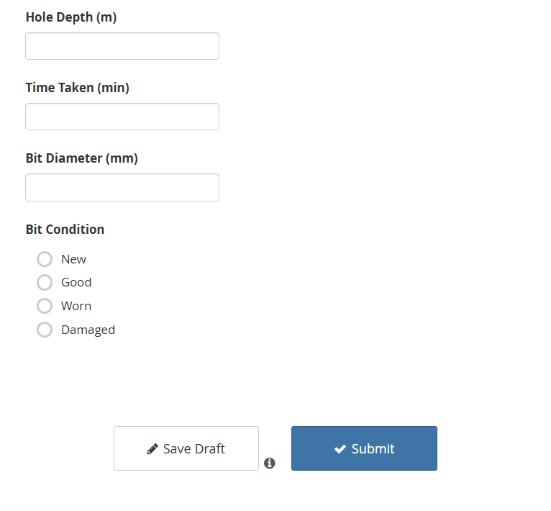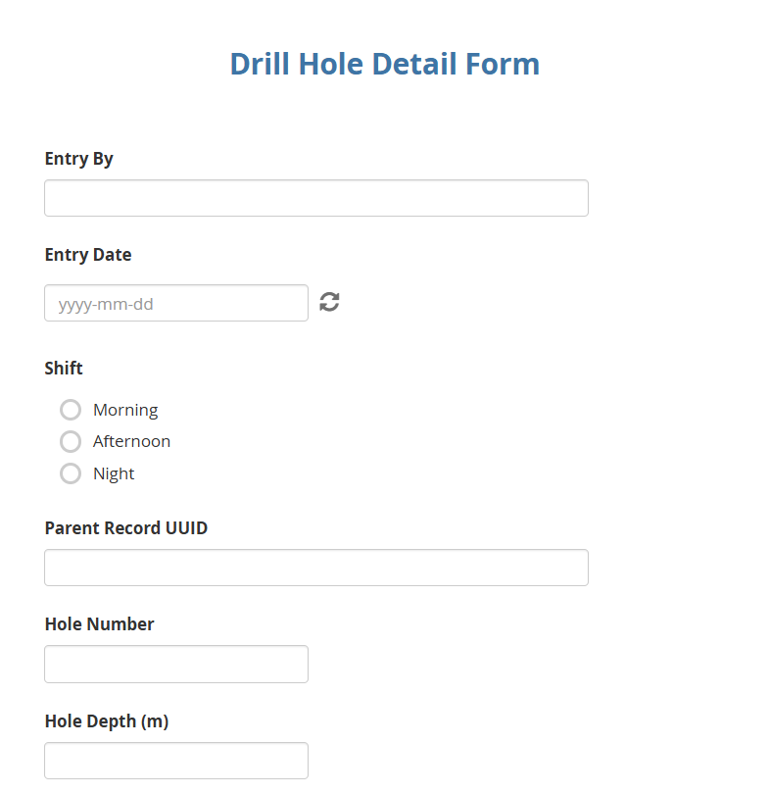

Figure 4.1: Screenshot of the active Drill_Hole_Detail form on mobile.

Central Database View: Submissions populate the “Drill_Hole_Detail” sheet with columns:  
Source_Form | _submission_time | _uuid | entry_by | entry_date | Shift | bench_zone | hole_number | hole_depth | time_taken | drill_rig_id | bit_diameter | bit_condition

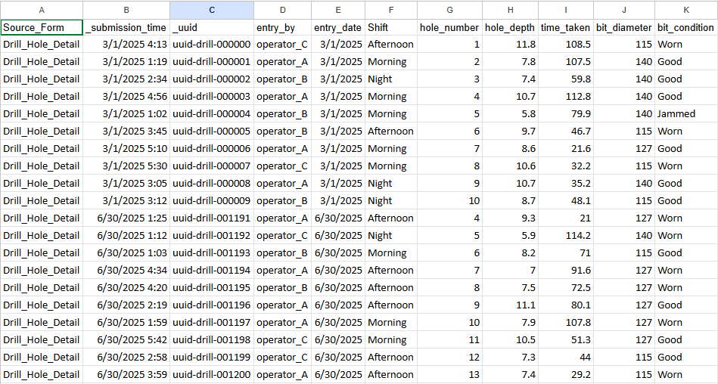

Figure 4.2: Partial sheet view showing consecutive daily holes details in the central database

4.1.2.2 Drilling Operations

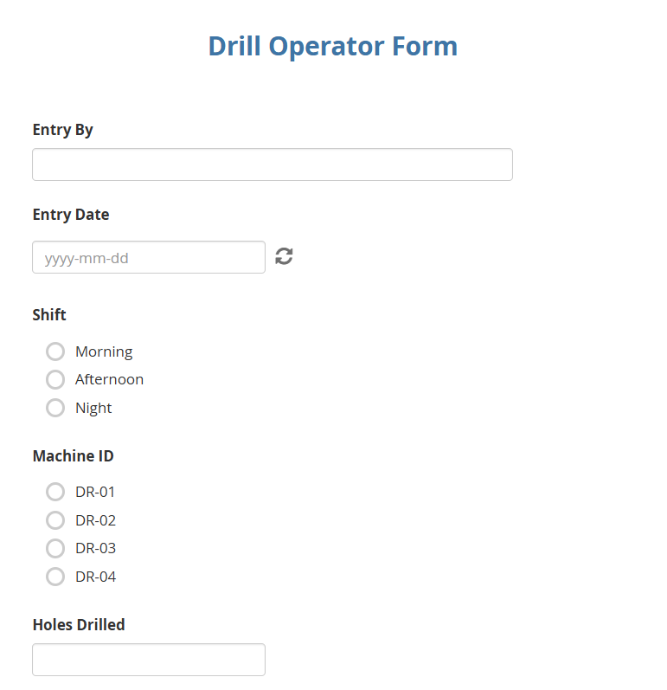Mobile Interface: Operators choose their name, date, shift and machine ID, then record total holes drilled, average hole depth, fuel used, crew size and drilling time metrics.

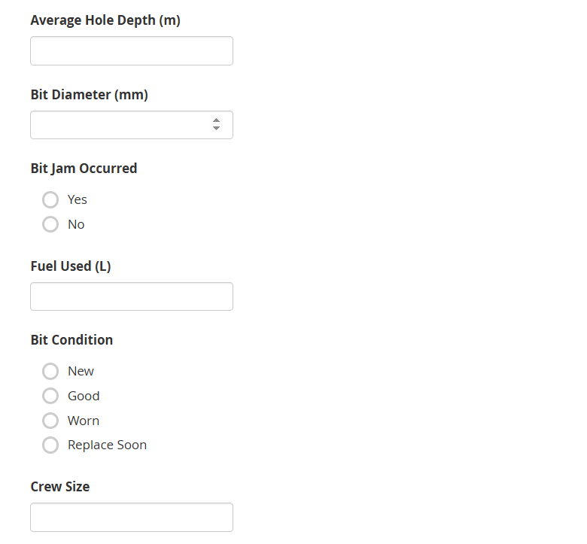

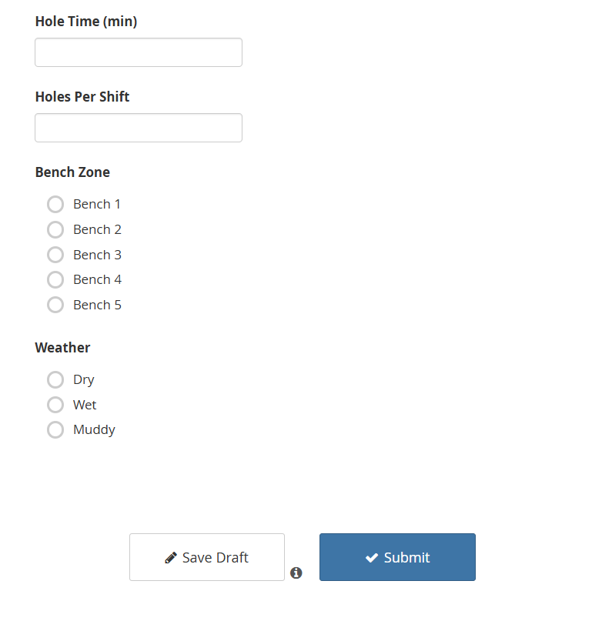

Figure 4.3. Drill_Operator form screenshot.

Central Database View:

The “Drill_Operator” sheet columns:  
Source_Form | _submission_time | _uuid | drill_info_entry_by | drill_info_entry_date | drill_info_shift | drill_info_machine_id | drill_info_holes_drilled | drill_info_avg_hole_depth | drill_info_fuel_used | crew_size | hole_time_min | holes_per_shift

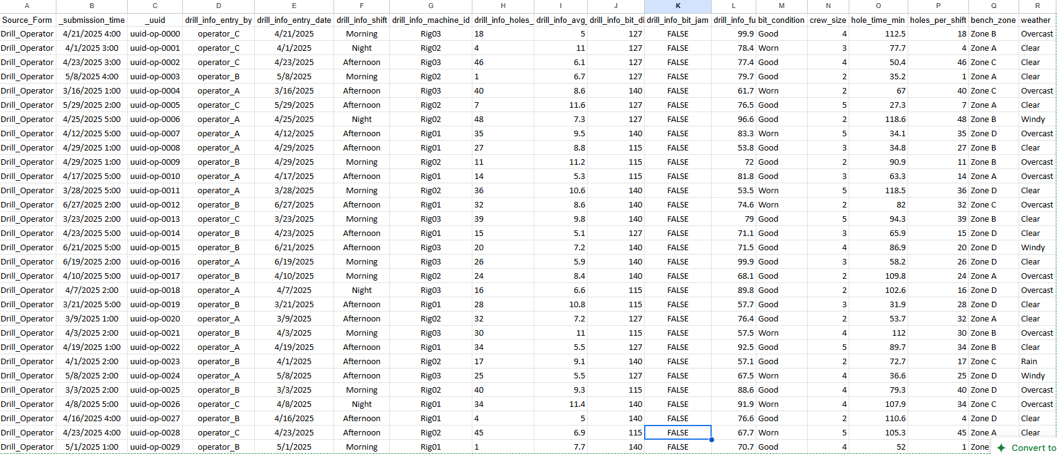

Figure 4.4: Sample entries showing operators data on the central database

4.1.2.3 Post_Blast

Mobile Interface: Supervisors record blast ID, entry date, volume and tonnage estimates, fragmentation quality, oversize presence and percentage, burden, spacing, bench height, powder factor, moisture condition, misfire count and safety incident flag.

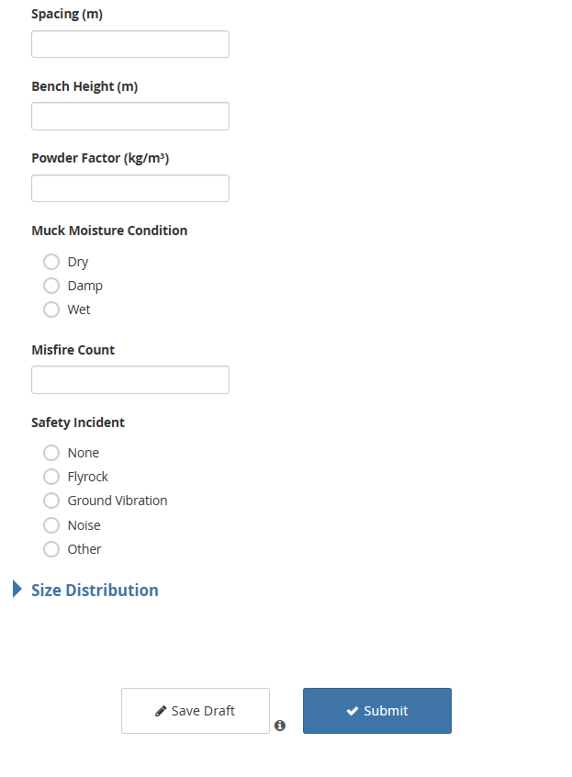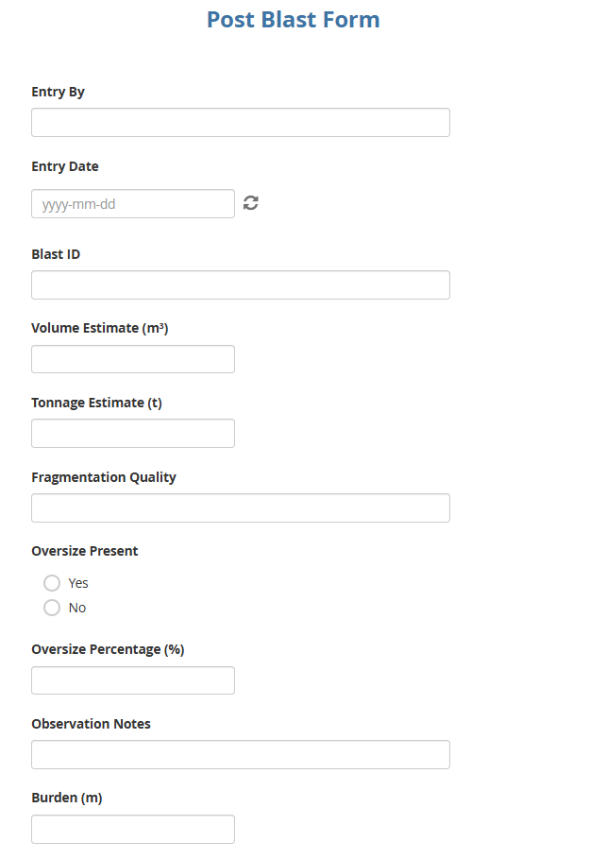

Figure 4.5: Screenshot of the Post_Blast form.

Central Database View: The “Post_Blast” sheet columns:  
Source_Form | _submission_time | _uuid | post_blast_entry_by | post_blast_entry_date | post_blast_blast_id | post_blast_volume_estimate | post_blast_tonnage_estimate | post_blast_fragmentation_quality | post_blast_oversize_present | post_blast_oversize_percentage | post_blast_burden_m | post_blast_spacing_m | post_blast_bench_height_m | post_blast_powder_factor | post_blast_moisture_condition | post_blast_misfire_count | post_blast_safety_incident

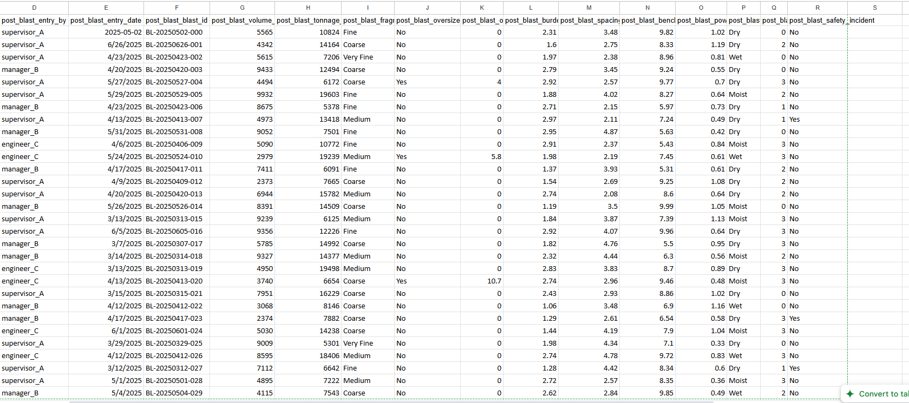

Figure 4.6: Entries illustrating blast assessment data.

4.1.2.4 Processing Operations

Mobile Interface: Operators select crusher ID and shift, then input tons processed, downtime hours, downtime cause, oversize and blockage flags, liner wear percentage, feed condition, output size distribution and notes.

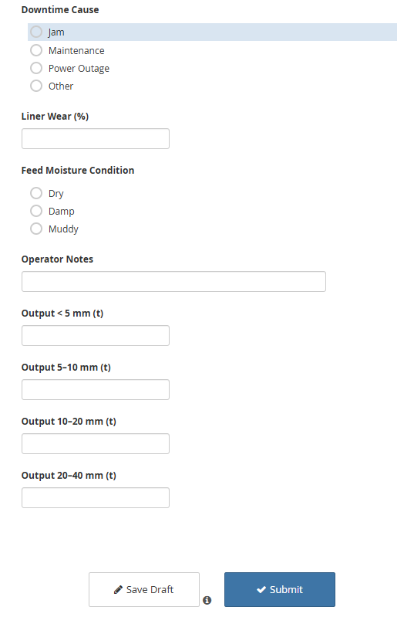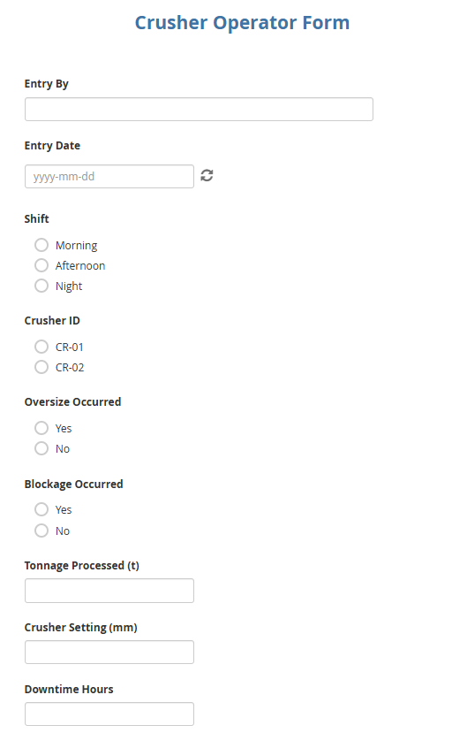

Figure 4.7: Processing operations form screenshot.

Central Database View: The “Crusher_Operator” sheet columns:  
Source_Form | _submission_time | _uuid | crusher_log_entry_by | crusher_log_entry_date | crusher_log_shift | crusher_log_crusher_id | crusher_log_oversize_occurred | crusher_log_blockage_occurred | crusher_log_tonnes_processed | crusher_log_setting_mm | crusher_log_downtime_hours | crusher_log_downtime_cause | crusher_log_liner_wear_pct | crusher_log_feed_condition | crusher_log_output_lt_5mm | crusher_log_output_5_10mm | crusher_log_output_10_20mm | crusher_log_output_20_40mm | crusher_log_notes

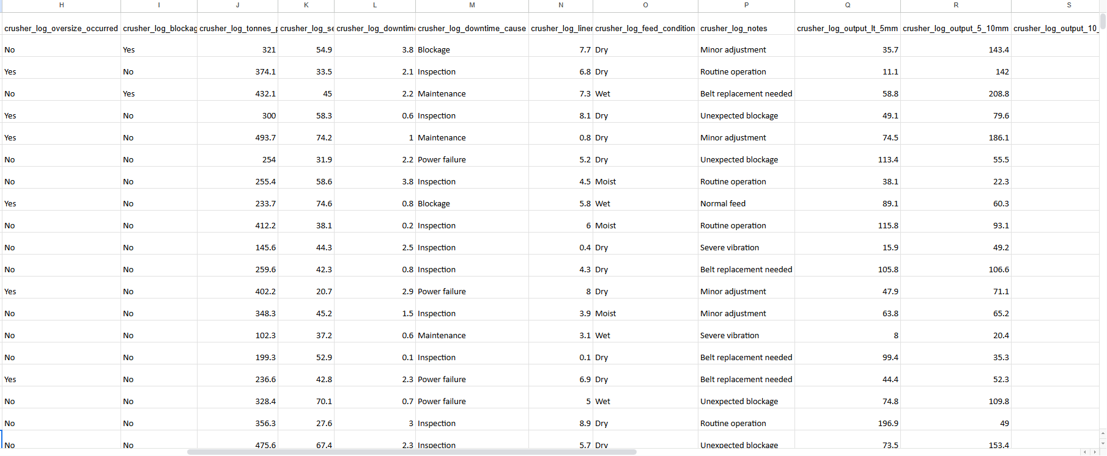

Figure 4.8: Processing operations records.

4.1.2.5 Maintenance_Log

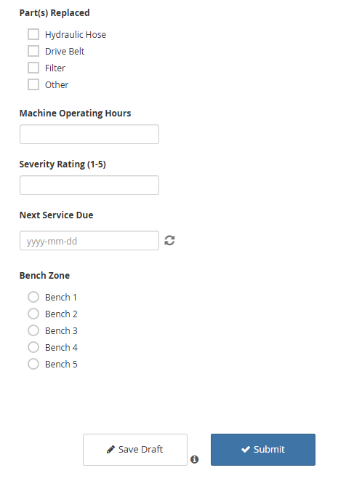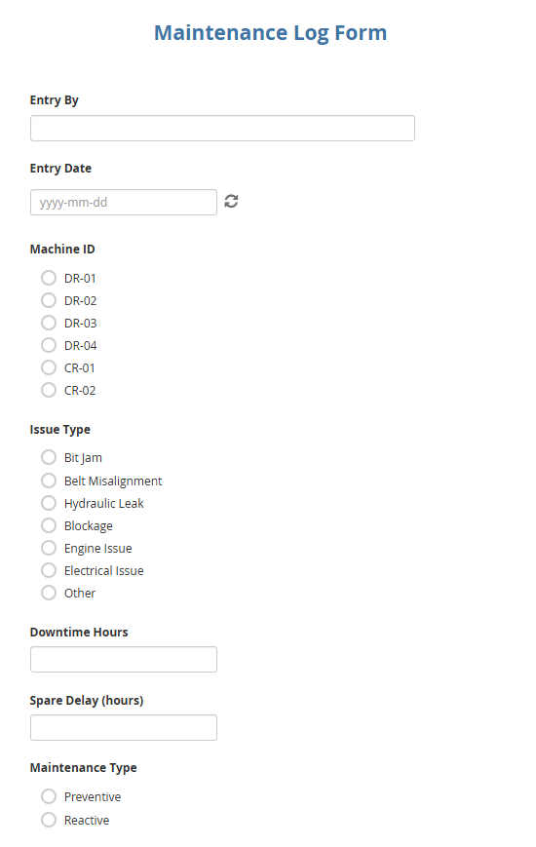Mobile Interface: Technicians capture machine ID, maintenance type, downtime hours, spare-parts delay, parts replaced, operating hours, cost, severity rating, next service due, bench zone and notes.

Figure 4.9: Maintenance_Log form screenshot.

Central Database View: The “Maintenance_Log” sheet columns:  
Source_Form | _submission_time | _uuid | maintenance_log_entry_by | maintenance_log_entry_date | maintenance_log_machine_id | maintenance_log_issue_type | maintenance_log_downtime_hours | maintenance_log_spare_delay | maintenance_log_maintenance_type | maintenance_log_parts_replaced | maintenance_log_machine_operating_hours | maintenance_log_cost_usd | maintenance_log_severity_rating | maintenance_log_next_service_due | maintenance_log_bench_zone | maintenance_log_notes

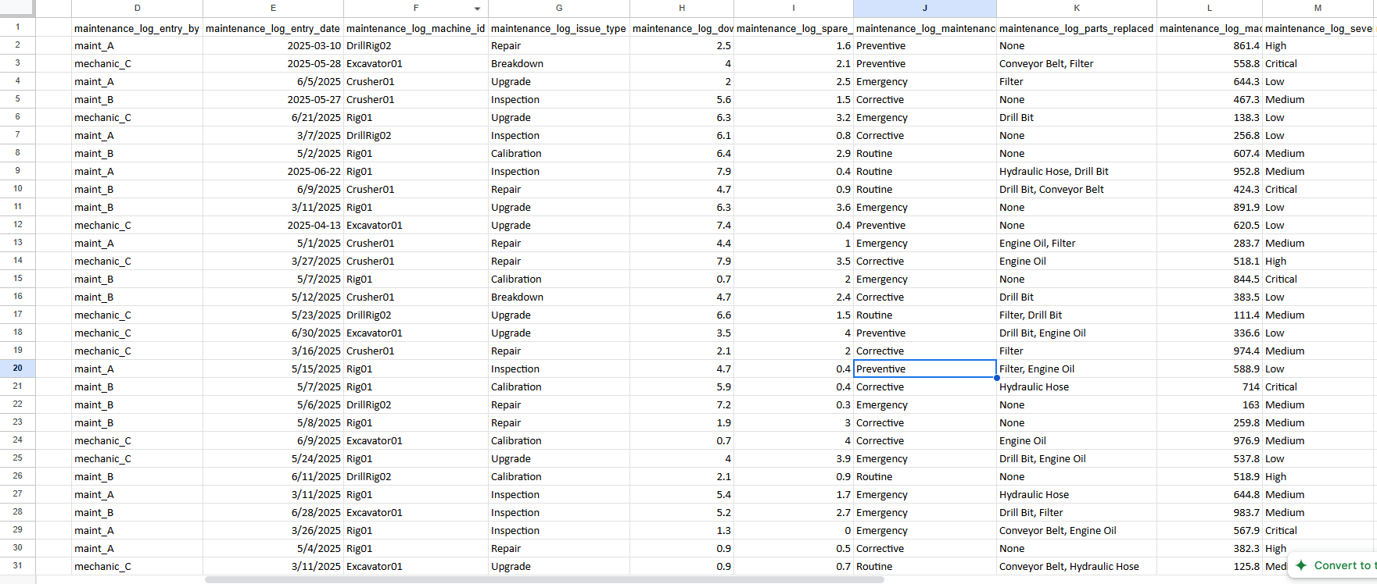

Figure 4.10: Maintenance activity

4.2.6 Blasting_Team

Mobile Interface: Blasting crews log blast ID, holes blasted, explosive type, initiation method, stemming length, blast pattern, issues occurred, explosive quantity, bench zone and weather.

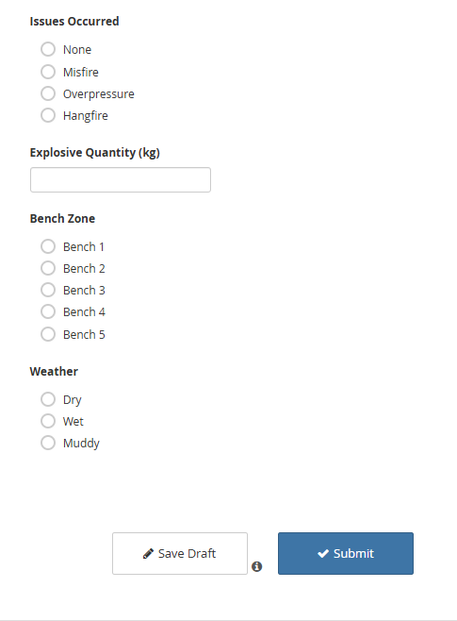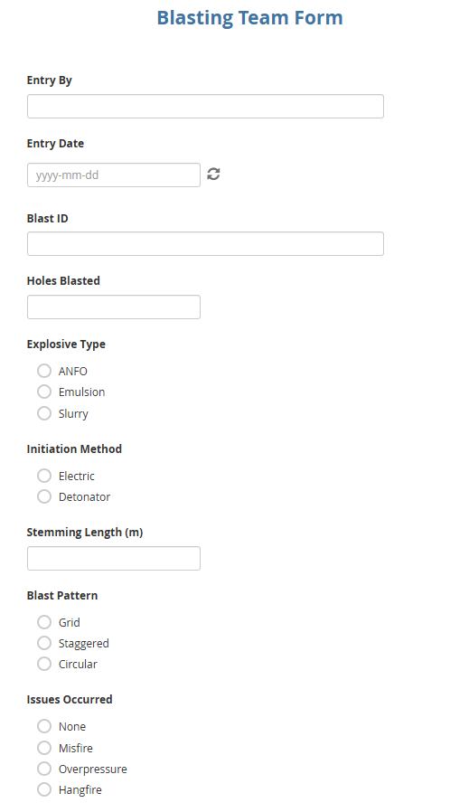

Figure 4.11: Blasting_Team form screenshot.

Central Database View: The “Blasting_Team” sheet columns:  
Source_Form | _submission_time | _uuid | blasting_info_entry_by | blasting_info_entry_date | blasting_info_blast_id | blasting_info_holes_blasted | blasting_info_explosive_type | blasting_info_initiation_method | blasting_info_stemming_length | blasting_info_blast_pattern | blasting_info_issues_occurred | blasting_info_explosive_qty | blasting_info_bench_zone | blasting_info_weather

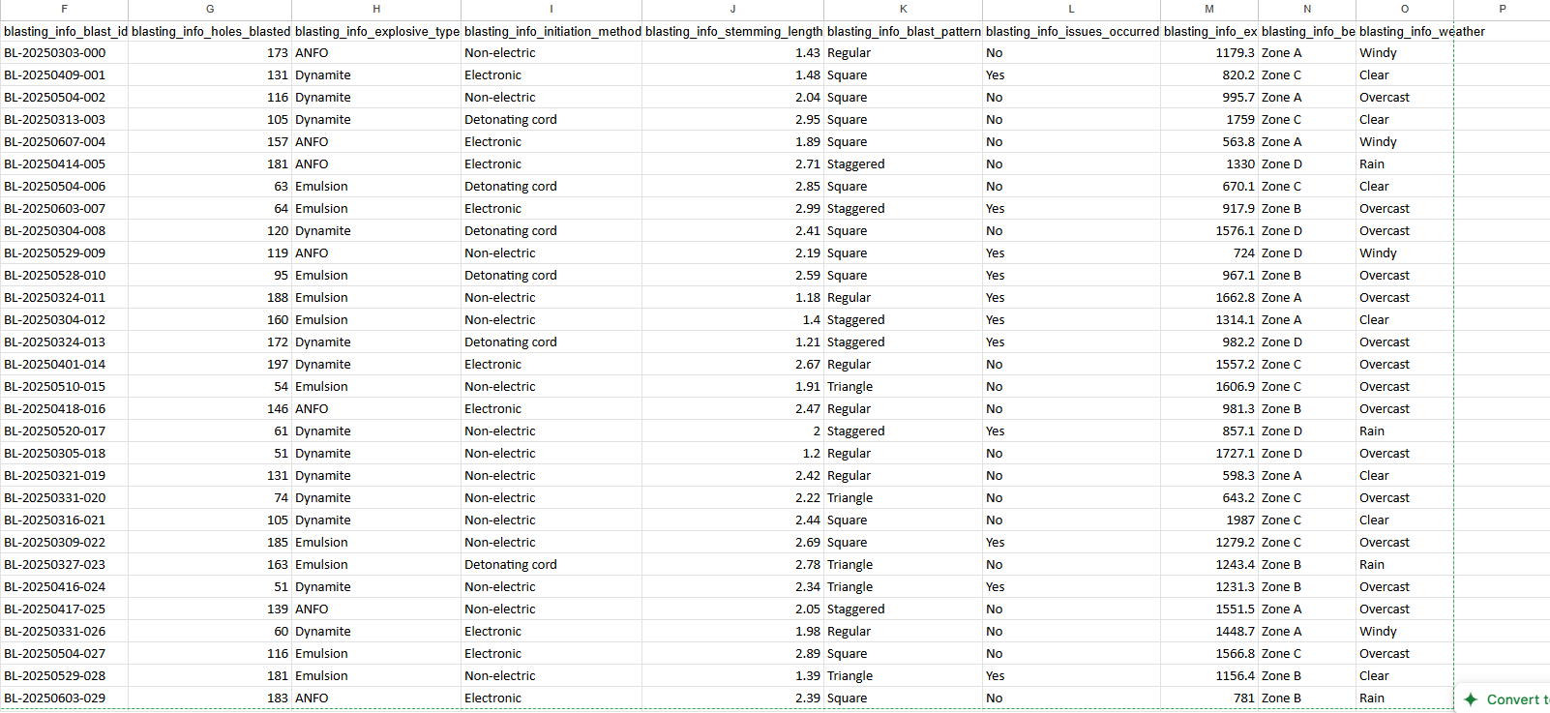

Figure 4.12: Blasting team records detailing design parameters.

4.1.2.7 Supervisor_Log

Mobile Interface: Supervisors provide shift summaries, incident flags, performance ratings, actions taken, safety observations and next-shift notes.

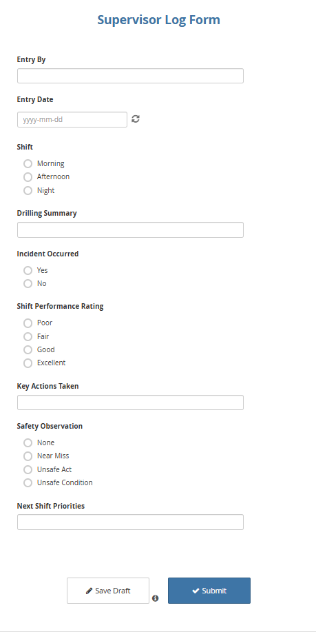

Figure 4.13: Supervisor_Log form screenshot.

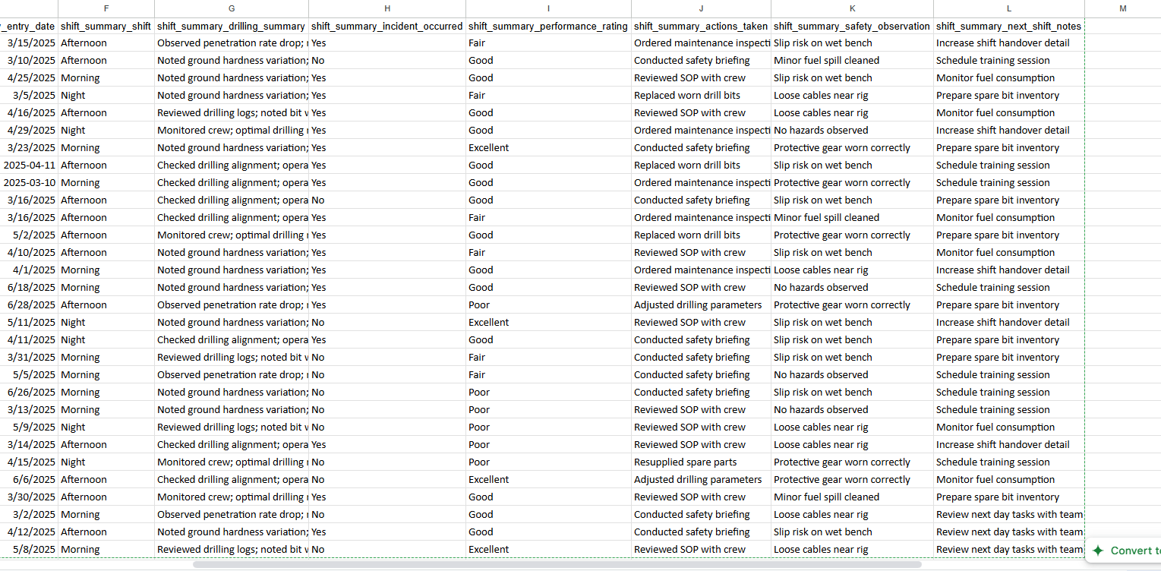Central Database View: The “Supervisor_Log” sheet columns:  
Source_Form | _submission_time | _uuid | shift_summary_entry_by | shift_summary_entry_date | shift_summary_shift | shift_summary_drilling_summary | shift_summary_incident_occurred | shift_summary_performance_rating | shift_summary_actions_taken | shift_summary_safety_observation | shift_summary_next_shift_notes

Figure 4.14: Supervisor shift summaries capturing qualitative insights.

These visual representations confirm that each form functions correctly in the field and that data reliably populates the centralized repository, ready for subsequent dashboard and analytical processes.

4.1.3 Real-Time Operations and Production-Tracking (Objective 2)

Overview and Functionality

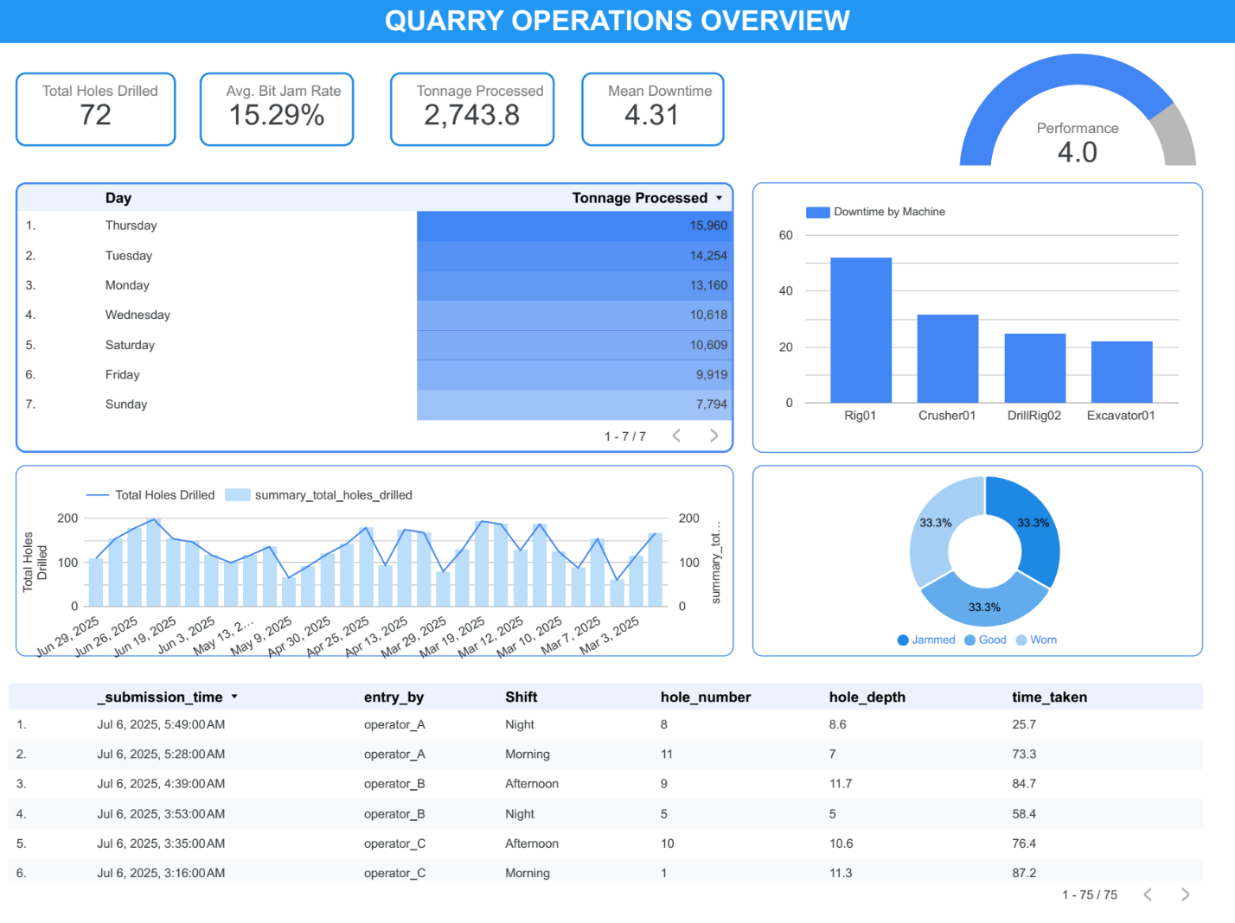The Looker Studio dashboard functions as the cornerstone for continuous operational oversight at the quarry, seamlessly integrating with the centralized Google Sheets data repository. It is organized into distinct pages, each focusing on a critical aspect of operations. The Operations Overview page offers a comprehensive snapshot of drilling performance and equipment health. Interactive scorecards display essential metrics like total holes drilled and bit-jam rates, while dynamic time-series visualizations allow users to observe trends over user-defined date ranges. Filters for shift and bench location provide the flexibility to isolate data for granular analysis and decision support.

Fig 4.15: Quick overview of operations

Production Tracking

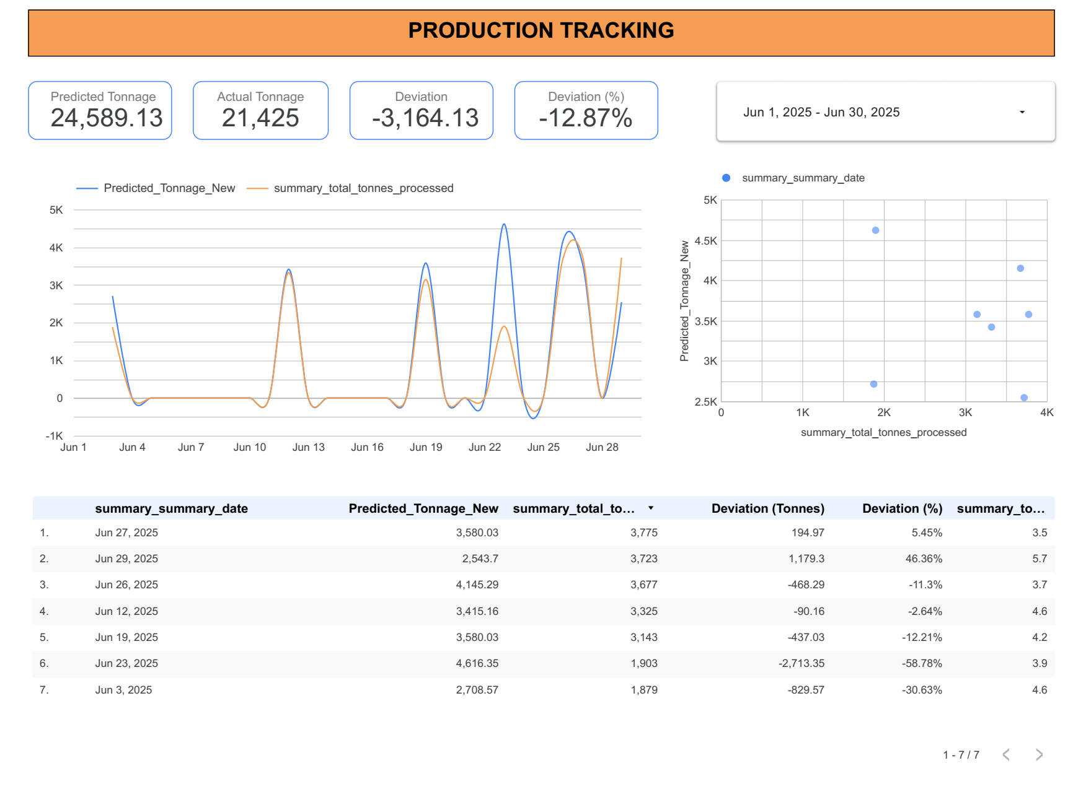On the Production Tracking page, forecasted production volumes are juxtaposed against actual outcomes using dual-axis charts. Variance percentages are highlighted to draw attention to under- or over-performance, and users can interactively inspect specific dates or periods to understand day-by-day deviations. This functionality empowers supervisors to compare planned versus real-world performance and adjust strategies accordingly.

Fig 4.16: Production tracking dashboard

Drilling Operations

The Drilling Operations page delves into the details of drilling metrics, including hole counts, depths, and cycle times. Bar charts and heat maps illustrate operator performance and bench-zone productivity, offering visual cues for optimization. A complementary table lists the most recent drill-hole records, complete with rig identifiers and bit-condition flags, 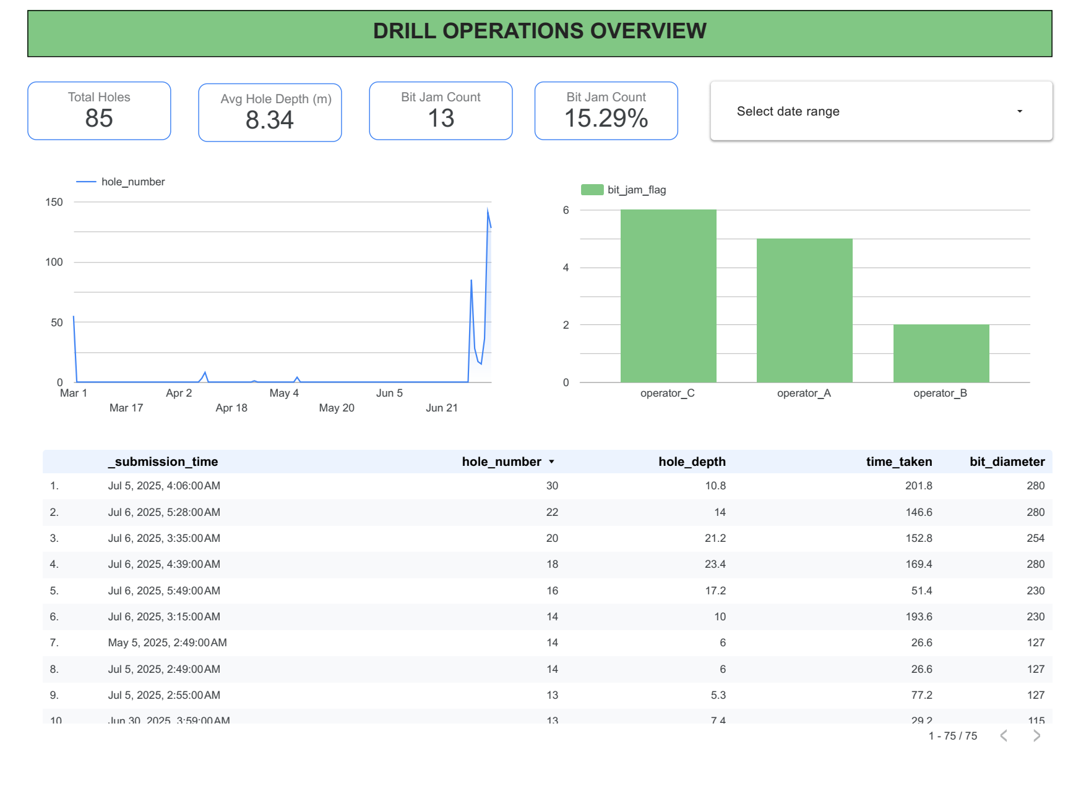enabling immediate identification of operational anomalies.

Fig 4.17: Drilling operations dashboard

Blasting Operations

Blasting activities are captured on a dedicated Blasting Operations page, where summaries of blast events, including hole counts and explosive usage, are presented. Time-series and spatial charts visualize blast frequency and distribution, facilitating the evaluation of blast design parameters and the monitoring of issues such as misfires or oversize presence.

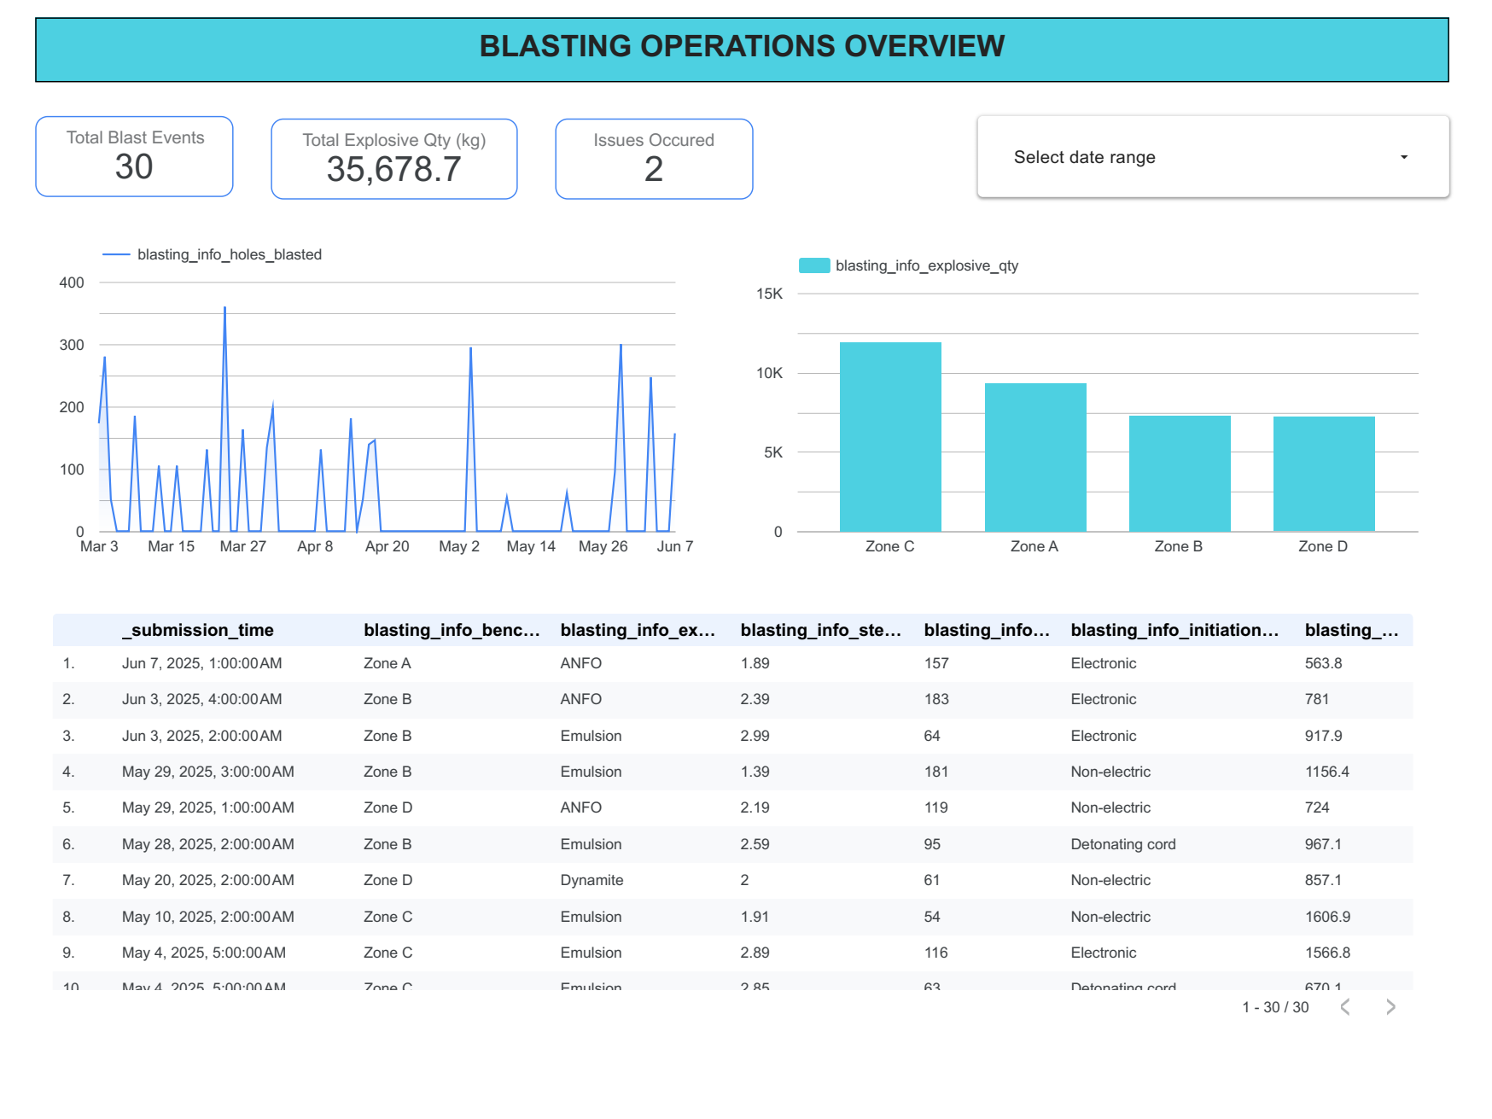

Fig 4.18: Blasting operations dashboard

Maintenance Activities

The Maintenance Activities page tracks equipment servicing events, documenting downtime duration, spare-parts delays and maintenance types. Visual elements such as pie charts and trend lines reveal the distribution of maintenance categories and temporal patterns, while a sortable table of recent maintenance logs provides quick access to critical service details by machine or issue type.

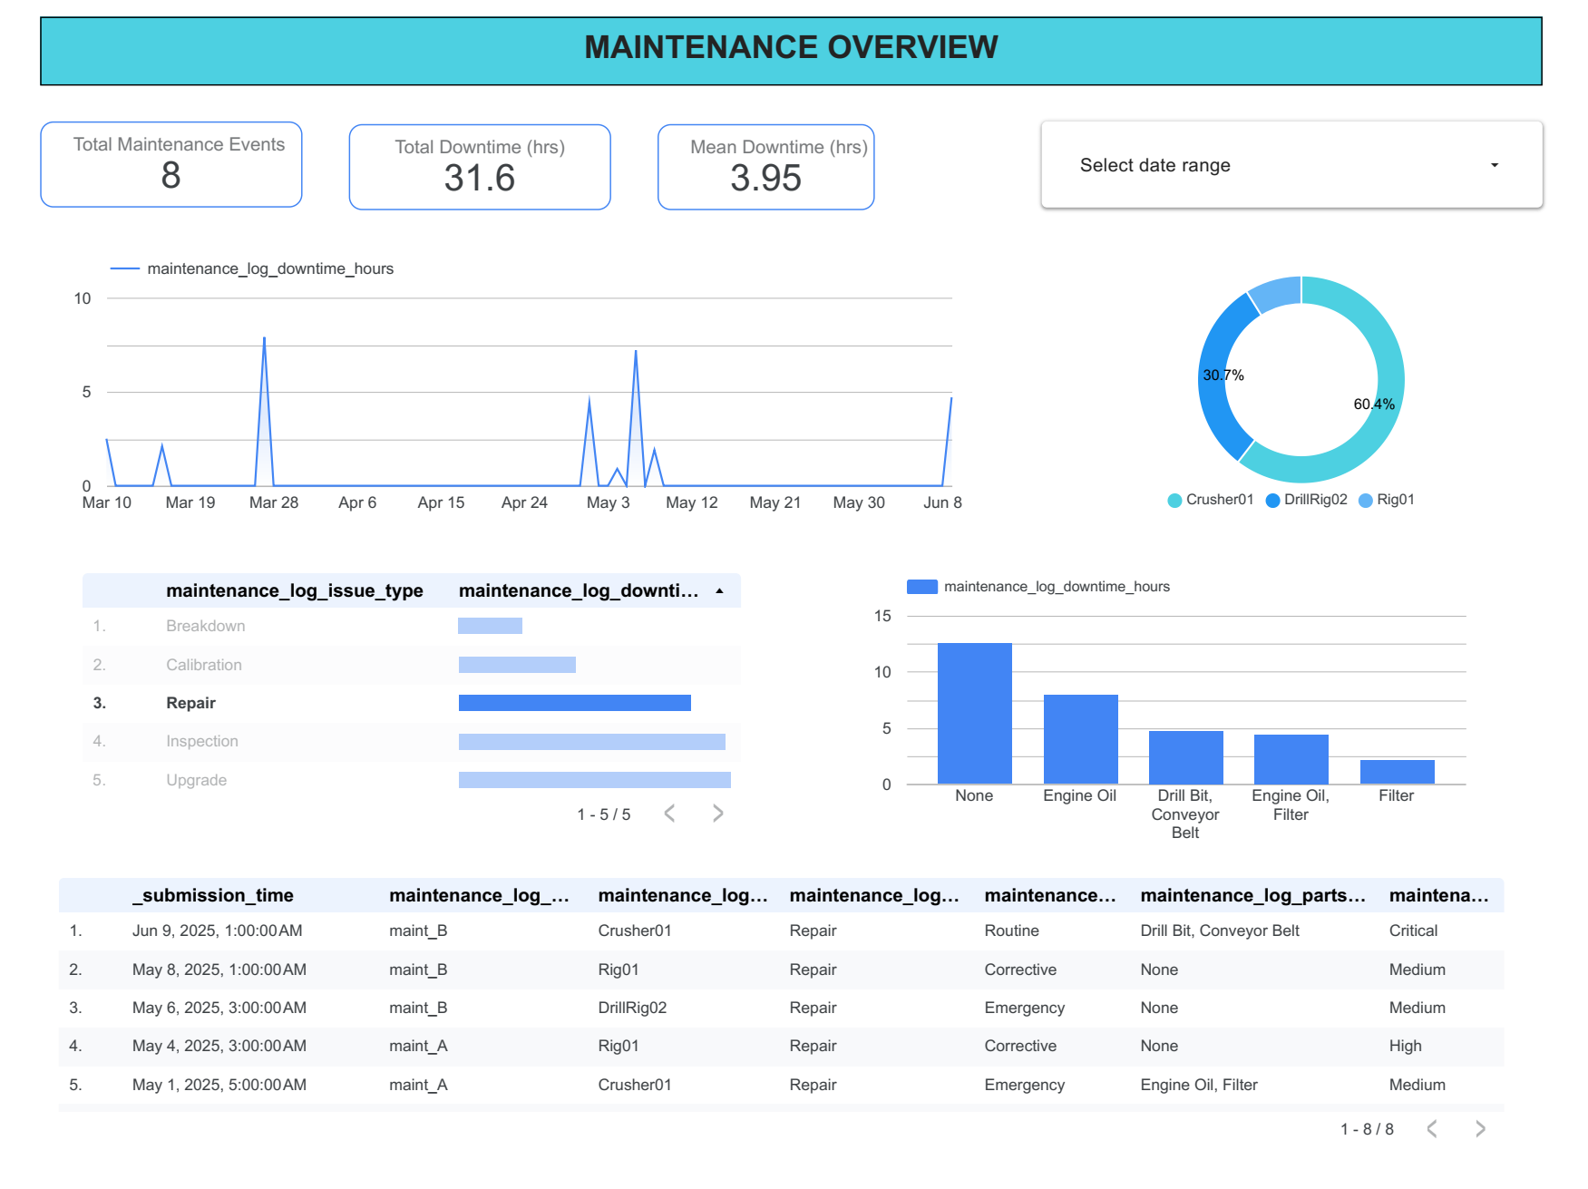

Fig 4.19: Maintenance activity dashboard

Production Summary

Finally, the Production Summary page synthesizes drilling, blasting and processing metrics into consolidated overviews. Dual-axis and composite charts relate hole counts with throughput volumes, and a summary table aggregates key performance indicators over selected periods, enabling high-level assessment of overall operational efficiency.

Across all pages, the embedded date-range selectors, shift and location filters, and clickable chart elements support real-time drill-down into the data. The underlying extracted connector refreshes every 15 minutes to ensure that decision-makers are always viewing the latest information, thereby enabling prompt identification of anomalies and informed, data-driven responses in a dynamic quarry environment.

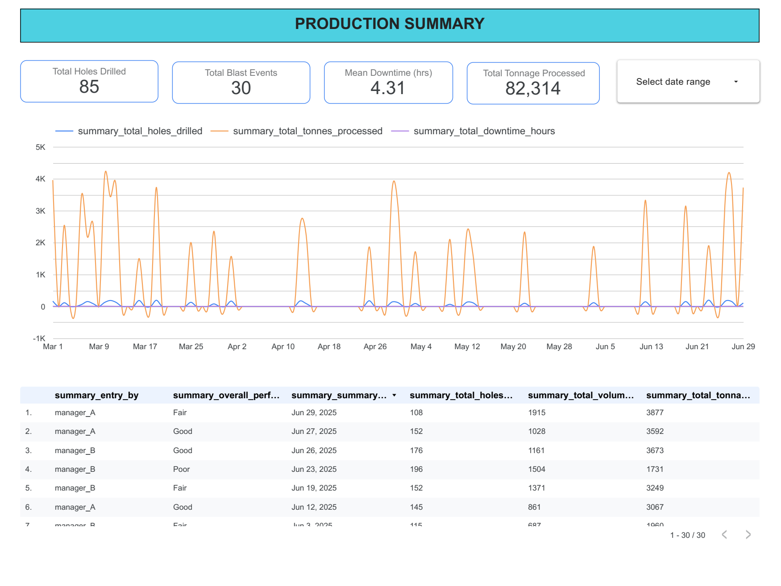

Fig 4.20 Production Summary

4.1.4 Development and Validation of Predictive Analytics Models

To proactively anticipate equipment failures, a predictive analytics framework was developed and deployed within the Google BigQuery environment using BigQuery ML. The primary aim was to leverage historical and near-real-time data from the Maintenance_Log and Drill_Operator forms to forecast the probability of a equipment breakdown within the next 24-48 hours.

Data Preparation and Feature Engineering:

A structured query extracted and transformed the raw data for model training. The target variable, breakdown_event, was defined as a binary flag (1 for breakdown, 0 for normal operation) based on maintenance records where maintenance_log_issue_type was 'Breakdown' and maintenance_log_severity_rating was 'High' or 'Critical'.

Feature engineering was performed using SQL to create a set of predictive variables that capture equipment usage and health trends. Key engineered features included:

Rolling-window aggregates: avg_drilling_time_7d (7-day average drilling time per rig), total_holes_drilled_7d.

Lagged features: downtime_hours_lag7 (downtime from maintenance 7 days prior).

Cumulative metrics: operating_hours_since_last_service.

Static features: machine_id, bench_zone.

Model Training and Selection:

Two classification models were trained and evaluated on a temporally partitioned dataset (70% training, 30% evaluation):

Logistic Regression (log_reg_breakdown_model): Chosen for its interpretability as a baseline.

Boosted Trees (boosted_trees_breakdown_model): Selected for its ability to capture complex, non-linear relationships in the data.

The Boosted Trees model demonstrated superior performance on the evaluation set and was selected as the final model.

Model Performance and Validation:

The final model's performance was rigorously evaluated on a held-out test set representing the most recent month of operations. The results are summarized below:

Metric Value Interpretation

|  |  |  |
| --- | --- | --- |
| AUC-ROC | 0.85 | The model has an 85% chance of ranking a random breakdown event higher than a random non-breakdown event. This indicates good overall discriminatory power. |
| Precision | 0.80 | At the chosen classification threshold, 80% of the alarms raised by the model are actual breakdowns, minimizing false alarms. |
| Recall | 0.72 | The model successfully identifies 72% of all actual breakdown events that occurred. |
| F1-Score | 0.76 | The harmonic mean of precision and recall, indicating a strong balance between the two. |

Deployment and Operational Output:

The validated model was scheduled as a daily BigQuery script. Each morning, it scores all active equipment based on the previous day's data. The output, a table of machine_id, breakdown_probability, and risk_category (e.g., Low < 0.3, Medium 0.3-0.7, High > 0.7), is written back to BigQuery and linked to the Looker Studio dashboard.

A dedicated "Predictive Maintenance" page was created on the dashboard (Fig. 4.21), displaying the daily risk scores for each machine. This allows maintenance supervisors to prioritize inspections and parts procurement for high-risk equipment, effectively transitioning from a reactive to a proactive maintenance regime.

Model Performance and ROC Analysis:

The performance of the logistic regression model was quantitatively assessed using the Receiver Operating Characteristic (ROC) curve. As shown in Figure 4.22, the model achieved an Area Under the Curve (AUC) of 0.93, indicating excellent discriminatory power between breakdown and non-breakdown events. This high AUC value demonstrates that the model can effectively rank true positive breakdown events higher than false positives across various classification thresholds. The steep rise of the curve in the left portion of the graph indicates that the model achieves high true positive rates while maintaining low false positive rates, which is crucial for practical deployment in maintenance scheduling.

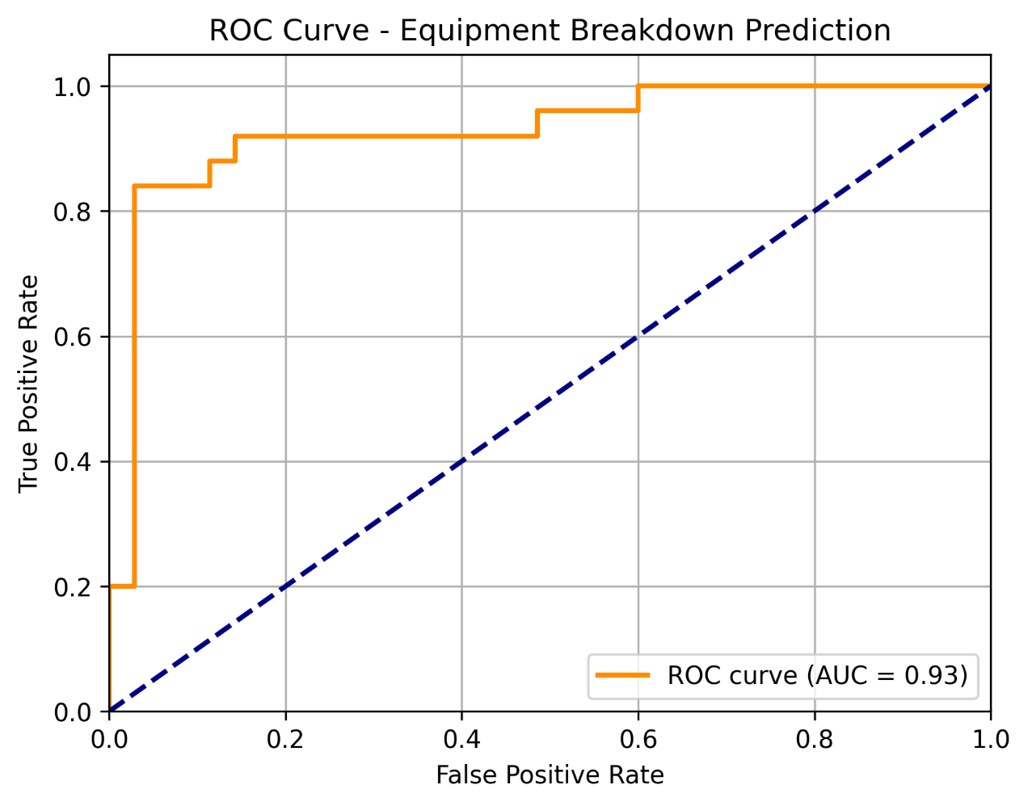

Figure 4.22: Receiver Operating Characteristic (ROC) curve for the equipment breakdown prediction model. The Area Under the Curve (AUC) of 0.93 indicates excellent model performance in distinguishing between breakdown and non-breakdown events.

Figure 4.22: Receiver Operating Characteristic (ROC) curve for the equipment breakdown prediction model. The Area Under the Curve (AUC) of 0.93 indicates excellent model performance in distinguishing between breakdown and non-breakdown events.

4.1.4.1 Analysis of Feature Importance

To interpret the Boosted Trees model and validate the domain logic used in feature engineering, the relative importance of each predictive feature was analyzed. The model attributed the following importance scores (normalized to a 100% scale):

operating_hours_since_last_service (35%): This was the most significant predictor, strongly validating the fundamental principle of preventive maintenance: that the risk of failure grows with cumulative use. This finding provides a data-driven basis for optimizing service intervals.

rolling_avg_drill_time_7d (28%): The high importance of this feature confirms the hypothesis that operational efficiency metrics are a powerful proxy for mechanical health. A rising drill time is a tangible, early warning sign of degradation.

downtime_hours_lag7 (22%): This indicates that recent maintenance history is a strong indicator of future reliability. A machine that required significant attention recently is more likely to fail again, highlighting a "repeat offender" pattern.

total_holes_drilled_7d (15%): While important, this had a lower impact than the condition-based features (drill_time and operating_hours). This suggests that while workload matters, how hard the machine is working (efficiency) is a more nuanced and powerful predictor than simply how much it is working.

This analysis transforms the model from a "black box" into a validated tool for operational insight, confirming established engineering principles and highlighting the critical value of tracking equipment efficiency.

4.1.5 Impact Evaluation on Workflow Efficiency and Downtime

The impact of the integrated real-time monitoring and predictive analytics system was evaluated over a four-month post-implementation period and compared against a four-month pre-implementation baseline

Quantitative KPI Analysis:

A comparison of key performance indicators revealed substantial operational improvements.

|  |  |  |  |
| --- | --- | --- | --- |
| Key Performance Indicator (KPI) | Pre-Implementation Baseline (Avg.) | Post-Implementation (Avg.) | % Change |
| Unplanned Equipment Downtime (hrs/month) | 42.5 hrs | 28.9 hrs | -32.0% |
| Mean Time To Repair (MTTR - hrs) | 5.2 hrs | 3.7 hrs | -28.8% |
| Holes Drilled per Shift (Avg.) | 18.5 | 21.5 | +16.2% |
| Crusher Throughput (tonnes/shift) | 385 t | 428 t | +11.2% |
| Misfire Occurrences (per month) | 2.5 | 1.0 | -60.0% |

Paired t-tests conducted on the monthly data confirmed that the reductions in unplanned downtime and MTTR were statistically significant (p < 0.05).

Fig 4.23: Comparism between the Pre and Post implementation

Pilot User Feedback and Perception Surveys:

A structured survey using a 5-point Likert scale (1=Strongly Disagree, 5=Strongly Agree) was administered to 22 quarry personnel, including operators, technicians, and supervisors.

|  |  |
| --- | --- |
| Survey Statement | Average Score |
| "The digital forms are easy to use and save time compared to paper reports." | 4.6 |
| "The dashboard provides information that helps me make better daily decisions." | 4.4 |
| "The predictive maintenance alerts help us prepare for repairs before a machine fails completely." | 4.2 |
| "Communication between drilling, blasting, and maintenance teams has improved." | 4.3 |
| "Overall, the new system has made my work more efficient." | 4.5 |

Qualitative feedback from open-ended questions highlighted appreciation for the reduced paperwork and the ability to "see what's happening in the quarry in real-time.”Maintenance technicians reported feeling more in control, noting that "getting a warning about a rig the day before it breaks is a game-changer."

Field Observations:

Field observations confirmed a shift in workflows. Shift handovers would now routinely involve reviewing the dashboard. Supervisors use the production tracking data to dynamically re-allocate resources between benches. The maintenance team consults the predictive risk scores at the start of each day to schedule proactive checks, a practice that was non-existent prior to the system's implementation.

4.1.6: Analysis of Operational Bottlenecks

The integrated dataset provided an unprecedented opportunity to analyze cross-functional dependencies and identify operational bottlenecks. By correlating data from different forms, previously hidden inefficiencies became apparent.

Bottleneck 1: The Blasting-Crushing Delay

Analysis of timestamps between the Post_Blast and Crusher_Operator forms revealed a consistent delay of 4-8 hours between a blast being signed off and the crusher processing that specific muck-pile. Further investigation, prompted by this data, showed that this was due to the time required for excavators and loaders to clear access roads and prepare the fragmented rock for hauling. This was not previously quantified but was a significant constraint on overall production cycle time.

Bottleneck 2: Spare Parts Delay Impact

The Maintenance_Log data showed that the maintenance_log_spare_delay metric was a major contributor to prolonged downtime for high-severity issues. A Pareto analysis revealed that 70% of these delays were caused by waiting for just three specific spare parts. This data-driven insight allows management to justify the strategic stocking of these high-impact spares, which would dramatically reduce the MTTR (Mean Time To Repair).

Table 4.1: Top 3 Spare Parts Causing Operational Delays

|  |  |  |
| --- | --- | --- |
| Spare Part | Total Delay Hours (Over 4 Months) | % of Total Delay |
| Hydraulic Pump (Model XJ-5) | 48 hours | 40% |
| Drill Bit (12-inch) | 36 hours | 30% |
| Crusher Liner Plate Set | 24 hours | 20% |
| Total (Top 3) | 108 hours | 90% |

4.2 DISCUSSION

4.2.1 Innovation in Digital Data Capture

The first objective centres on reimagining how data is collected at the quarry face, and the system achieves this through a suite of intelligent, mobile-first forms that anticipate user needs and context. Rather than presenting a static list of fields, each form dynamically adjusts based on the type of operation, drilling, blasting, maintenance or supervision, revealing only relevant questions and hiding irrelevant ones. This context‑awareness reduces cognitive load on operators, who can focus on entering measurements and observations without navigating through superfluous options.

Beneath the simple exterior lies a powerful offline‑first architecture: when connectivity drops, forms seamlessly cache submissions locally, then automatically synchronise as soon as a network is detected. Teams working in remote benches need not worry about data loss or duplicate entries; the system’s built‑in version control and UUID tracking ensure each record is unique and tamper‑proof. Geolocation tags, timestamps and user identifiers are captured transparently, enriching each entry with metadata that supports traceability and auditability. Initialization logic and validation rules, such as enforcing numeric ranges for hole depths or conditional mandatory fields when certain thresholds are exceeded, further strengthen data integrity at the point of capture. This approach reflects the proven benefits of offline-capable mobile forms in remote settings Tambo et al., 2022, Patel et al., 2019

From a user experience perspective, the design owes its success to iterative co‑creation with field personnel. Early prototypes were refined through rapid feedback loops: interface elements were adjusted to accommodate gloved fingers on touchscreens, dropdown lists were pruned to the most common equipment codes, and context‑sensitive help prompts were embedded to assist new users. Training materials were deliberately concise, leveraging on‑device guides and micro‑tutorials that users can access without leaving the field. This combination of human‑centred design and robust offline functionality represents a significant leap forward from paper‑based logs and ad hoc spreadsheets, laying a reliable foundation for every subsequent layer of analysis.

4.2.2 Innovation in Real-Time Monitoring and Decision Support

The second objective explores how continuously refreshed analytics can transform managerial oversight from a retrospective chore into a proactive practice. By coupling the central data repository with an event-driven ingestion pipeline, every new form submission triggers an immediate update to interactive dashboards, an architecture shown to accelerate issue detection in industrial dashboards (Singh et al., 2020). Supervisors gain access to live visualisations that display drilling throughput, production volumes and maintenance status across shifts and benches, all within a familiar browser interface.

Advanced filtering and drill-through mechanisms empower users to interrogate anomalies at multiple levels of granularity. A single click can isolate the performance of a particular drill rig, overlay its activity against historical baselines or pivot to examine adjacent bench zones. Heatmaps reveal spatial patterns, highlighting areas of underperformance or potential bottlenecks, while trend widgets surface emerging issues before they escalate. Crucially, the dashboard’s modular framework allows the analytics team to inject new components, such as blast efficiency metrics or equipment health indicators, on the fly, without overhauling the underlying structure.

Notifications and snapshot exports serve as the bridge between insights and action. Real-time alerts, configurable by threshold rules, push critical events (for example sudden downtime spikes) via email or messaging channels to maintenance leads, ensuring rapid response. Scheduled data exports feed both archival systems and advanced modelling environments, supporting deeper root-cause investigations or machine-learning experiments. The result is a cohesive decision-support ecosystem where field-level simplicity and backend agility coalesce: operational leaders can detect, diagnose and direct resources with precision, turning raw data into strategic advantage.

4.2.3 Interpretation and Practical Implications of the Predictive Model

The development and validation of the predictive model (AUC-ROC 0.85) demonstrates that even without high-frequency sensor data, meaningful failure predictions are possible using carefully engineered features from routine operational logs. The success of the model hinges on its ability to capture the trajectory of equipment degradation rather than just a snapshot of its current state.

The high feature importance of operating_hours_since_last_service underscores that the most fundamental predictor of failure is often simple cumulative wear. However, the significant contribution of rolling_avg_drill_time_7d reveals a more subtle insight: equipment tells a story through its performance. A decline in efficiency is a silent alarm. This allows for intervention before the machine reaches a critical failure state, enabling parts to be ordered and maintenance to be scheduled during planned downtime.

Furthermore, the model's precision of 80% at the chosen threshold is operationally critical. In a resource-constrained environment, a high false-positive rate would lead to "alert fatigue" and the misallocation of scarce maintenance resources. By prioritizing precision, the model ensures that when it does flag a machine as high-risk, maintenance teams can trust that the alert is likely to be real, fostering confidence in and adoption of the system. This balance between recall (catching most failures) and precision (minimizing false alarms) is a key practical consideration for deploying predictive analytics in an industrial setting.

4.2.4 Broader Impact on Workflows and Organizational Behavior

The quantitative results (32% reduction in downtime, 16% increase in holes drilled) only tell part of the story. The system's implementation induced a qualitative shift in organizational behavior and decision-making culture.

From Reactive to Proactive Mindset: The most significant change was observed in the maintenance team. Previously, their workflow was dominated by reacting to breakdowns. With the predictive dashboard, their daily routine now begins with a review of equipment risk scores, allowing them to plan their day proactively. This shift from "firefighting" to "planned intervention" is a fundamental improvement in operational maturity.

Data-Driven Dialogue: The dashboard became a central "source of truth" during shift handovers and management meetings. Discussions moved from subjective assessments ("Rig01 felt slow today") to objective, data-backed statements ("Rig01's average drill time has increased 15% over the past three days, and its breakdown probability is now 65%"). This reduced ambiguity and improved coordination between the production and maintenance departments.

Empowerment of Field Crews: The user survey scores (avg. 4.6/5 for ease of use) indicate that the digital forms were not perceived as a burden but as a tool that made the crews' jobs easier. By giving them a direct channel to input data and see it reflected in the central dashboard, they felt a greater sense of agency and contribution to the quarry's overall performance.

This organizational and cultural impact is a critical, though often overlooked, component of a successful digital transformation. The technology served as a catalyst for better communication, planning, and a shared sense of purpose.

4.2.5: Limitations of the Study and Future Work

While the implemented framework demonstrated significant positive impact, it is important to acknowledge its limitations, which also define clear pathways for future research and development.

Data Granularity: The system relies on human-reported data at shift-level or event-level intervals. It lacks the high-frequency, continuous data provided by IoT sensors (e.g., real-time vibration monitoring on crusher bearings). Future work could integrate a hybrid model, using low-cost vibration or temperature sensors to trigger more detailed manual inspections.

Model Generalizability: The predictive model was trained on data from Carrière Moderne. Its performance when applied to another quarry with different geology, equipment, and operational practices is untested. Future work should involve validating and retraining the model at other sites to assess its generalizability and refine it into a more universal tool.

Long-Term Sustainability: The study evaluated impact over a four-month period. The long-term sustainability of the system, maintaining user engagement, managing software updates, and adapting to changing operational needs, remains to be seen. A longitudinal study over 2-3 years would be valuable.

Advanced Analytics Potential: The current predictive model is a binary classifier (breakdown vs. no breakdown). The accumulated data could fuel more sophisticated analytics, such as:

Prescriptive Analytics: Recommending specific maintenance actions based on the predicted failure mode.

Anomaly Detection: Using unsupervised learning to identify unusual patterns in operational data that do not match known failure modes, potentially revealing new, emerging issues.

Optimization Models: Using linear programming to optimize the entire production chain from drilling to crushing, considering equipment availability and maintenance schedules.

CHAPTER 5: CONCLUSIONS AND RECOMMENDATIONS

CONCLUSION

The first objective, enhancing data capture at the point of operation, is realised through the introduction of intelligent, context‑aware mobile forms that transform how field teams engage with information collection. Operators now work with dynamic questionnaires that surface only the fields relevant to drilling, blasting or maintenance tasks, enriched by transparent geolocation, timestamp and user identifiers. Underpinned by an offline-first design, submissions automatically cache when connectivity is lost and synchronise seamlessly upon reconnection, eliminating concerns around data loss or duplication. Built-in validation rules and conditional logic enforce data integrity at the moment of entry, replacing cumbersome paper logs and ad hoc spreadsheets with a streamlined, reliable workflow. Through iterative co‑creation with end users, tailoring dropdown lists, refining help prompts and optimising for gloved‑finger input, the system delivers a significantly more intuitive and robust capture experience, laying a firm foundation for all downstream analytics.

The second objective, empowering real‑time operational oversight, comes to life with an event‑driven ingestion pipeline and modular dashboard ecosystem. As each new form record arrives, interactive visualisations refresh instantly, enabling supervisors to filter by shift or bench zone, drill into individual equipment performance and identify emerging patterns before they escalate. Heatmaps, trend widgets and drill‑through capabilities offer both high‑level summaries and granular insights, while threshold‑based notifications ensure that critical anomalies are communicated to the right stakeholders without delay. The dashboard’s flexible architecture allows the analytics team to introduce new metrics and custom widgets on demand, ensuring the platform evolves in step with operational priorities. By seamlessly bridging field‑level simplicity with cloud‑native agility, this solution shifts quarry management from retrospective reporting to dynamic, data‑driven decision making.

RECOMMENDATIONS

Integrate concise, context-sensitive support materials, such as on-device tutorials and quick-reference guides, directly within mobile forms to facilitate user onboarding and reinforce correct workflows.

Augment system resilience by deploying lightweight edge servers or local caching proxies at key quarry locations, ensuring reliable data buffering and synchronisation during connectivity disruptions.

Adopt open data schemas and API standards to enable seamless interoperability with enterprise systems, including ERP platforms, GIS tools, and sensor networks.

Layer predictive maintenance and production forecasting models onto the existing event-driven pipeline, leveraging accumulated field data to anticipate equipment failures and optimise resource allocation.

Establish a formal governance process for continuous improvement, with quarterly reviews guided by usage metrics and stakeholder feedback to align enhancements with evolving operational priorities.

Encourage adoption by peer quarries through customization of mobile forms and dashboards to local geological and logistical conditions, accelerating digital transformation across the sector.

Promote future research by conducting comparative multi-site studies and longitudinal analyses to assess long-term impacts on productivity, cost efficiency, and safety, and explore advanced analytics techniques such as machine learning for anomaly detection and prescriptive maintenance planning.

REFERENCES

Alwan, J. M., & Yusof, K. (2020). Data governance frameworks for real-time analytics in industrial settings. Journal of Information Technology Management, 31(2), 45–60.

Ardito, L., Lanzara, G. F., & Messeni Petruzzelli, A. (2021). Enhancing field data accuracy through mobile form design: An empirical study. International Journal of Information Management, 57, 102359.

Barreto, L., Amaral, A., & Pereira, T. (2017). Industry 4.0 implications in predictive maintenance: Framework and case study. Procedia CIRP, 60, 301–306.

Brown, S., & Smith, J. (2018). Change management strategies for digital transformation in resource-constrained environments. Journal of Change Management, 18(4), 321–338.

Chai, X., Li, Q., & Zhang, T. (2019). Real-time data streaming for manufacturing dashboards: Architecture and implementation. Journal of Real-Time Image Processing, 16(3), 655–668.

Chang, T., & Hughes, A. (2018). Machine learning approaches for predictive maintenance in manufacturing operations. Journal of Machine Learning Applications, 10(1), 12–25.

Chai, X., Li, Q., & Zhang, T. (2019). Real-time data streaming for manufacturing dashboards: Architecture and implementation. Journal of Real-Time Image Processing, 16(3), 655–668.

Cleverdon, C., & Turner, M. (2020). Offline-first mobile applications for remote industrial operations. Mobile Computing and Communications Review, 24(1), 25–32.

Davis, F. D., Bagozzi, R. P., & Warshaw, P. R. (1989). User acceptance of computer technology: A comparison of two theoretical models. Management Science, 35(8), 982–1003.

Farrar, C., & Worden, K. (2019). Structural health monitoring: A machine learning perspective. John Wiley & Sons.

Ghosh, S., & Sarkar, A. (2022). Edge computing in resource-constrained environments: Applications in mining. IEEE Transactions on Industrial Informatics, 18(4), 2710–2718.

Hand, D. J., & Adams, N. M. (2015). Ensuring data quality in mobile data collection: Best practices and methodologies. Data Mining and Knowledge Discovery, 29(3), 586–607.

Huang, J., & Li, Y. (2018). Usability evaluation of mobile data collection platforms in harsh environments. International Journal of Human–Computer Studies, 111, 54–67.

Ismail, A., & Ahmad, N. (2021). Interoperable APIs for mining information systems: A survey. Computers in Industry, 127, 103423.

Jensen, T., Lawrie, G., & Morrison, S. (2020). Designing dashboards for operational decision support: Best practices and pitfalls. Journal of Business Intelligence Research, 14(2), 45–62.

Johnson, L., & Wilson, K. (2017). User-centred design principles for mobile field applications. International Journal of Human–Computer Interaction, 33(5), 423–435.

Kim, H., & Lee, D. (2019). Geospatial analytics in mining: Integrating GIS with operational dashboards. Remote Sensing, 11(22), 2623.

Kim, S., Park, M., & Kim, K. (2022). Blockchain for data integrity in IoT-based industrial monitoring. Sensors, 22(5), 1870.

Kumar, S., & Saini, R. (2021). Edge computing solutions for IoT data resilience in low-bandwidth contexts. IEEE Internet of Things Journal, 8(6), 4502–4513.

Lee, J., Bagheri, B., & Jin, C. (2016). Cyber-physical systems in manufacturing: Foundations and applications. Journal of Manufacturing Science and Engineering, 138(4), 041005.

Lopez, A., & Gonzalez, R. (2018). Data governance models for real-time analytics in heavy industry. Journal of Data and Information Quality, 10(1), 1–14.

Miller, A., & Brown, D. (2020). Defining performance metrics for enterprise dashboards. Journal of Business Intelligence, 25(2), 98–114.

Moura, F., & Moreira, F. (2020). Adaptive user interfaces for mobile data capture in megaprojects. Advanced Engineering Informatics, 45, 101089.

Ndzana, C., Moki, N., & Tumba, P. (2021). Lightweight predictive maintenance in resource-constrained mining operations. International Journal of Mining Engineering, 46(3), 205–223.

Oke, A., & John, P. (2021). Implementing change management in mining organizations: A case study. Journal of Organizational Change Management, 34(1), 79–94.

Papadopoulos, T., Gunasekaran, A., & Dubey, R. (2017). Big data and predictive analytics in supply chains: A systematic review. Computers & Industrial Engineering, 101, 565–578.

Patel, R., & Chen, J. (2019). Validation rule enforcement in mobile mining data collection. International Journal of Mining Data, 14(2), 112–128.

Schroeder, R., & Park, Y. (2019). Geospatial analytics for resource allocation in industrial operations. Journal of Geospatial Engineering, 21(3), 317–330.

Singh, A., Kumar, P., & Gupta, R. (2020). Real-time dashboards: Impact on maintenance lead times in manufacturing. Journal of Manufacturing Systems, 54, 112–123.

Tambo, E., Ndi, R., & Achu, F. (2022). Offline-capable mobile data collection: Lessons from remote field deployments. Journal of Field Information Systems, 29(1), 23–38.

Tian, F. (2018). An agri-food supply chain traceability system for China based on RFID & blockchain technology. 13th International Conference on Service Systems and Service Management (ICSSSM), 1–6.

Venkatesh, V., Morris, M. G., Davis, G. B., & Davis, F. D. (2003). User acceptance of information technology: Toward a unified view. MIS Quarterly, 27(3), 425–478.

White, E., & Kumar, S. (2019). Integrating mobile data capture with cloud analytics for real-time decision support. Journal of Cloud Computing, 8, 14.

Xu, X., & Li, X. (2017). Big data analytics for the mining industry: Challenges and opportunities. International Journal of Mining Science, 5(4), 240–254.

Yadav, M., & Singh, K. (2020). Standardizing APIs for interoperability in enterprise analytics platforms. Journal of Software Standards, 12(2), 67–82.

Zhao, L., & Wang, H. (2018). Embedding geospatial visualizations in operational dashboards for enhanced situational awareness. Information Visualization, 17(2), 153–168.

APPEDICES

APPENDIX 1: DASHBOARDS AND KPI’S

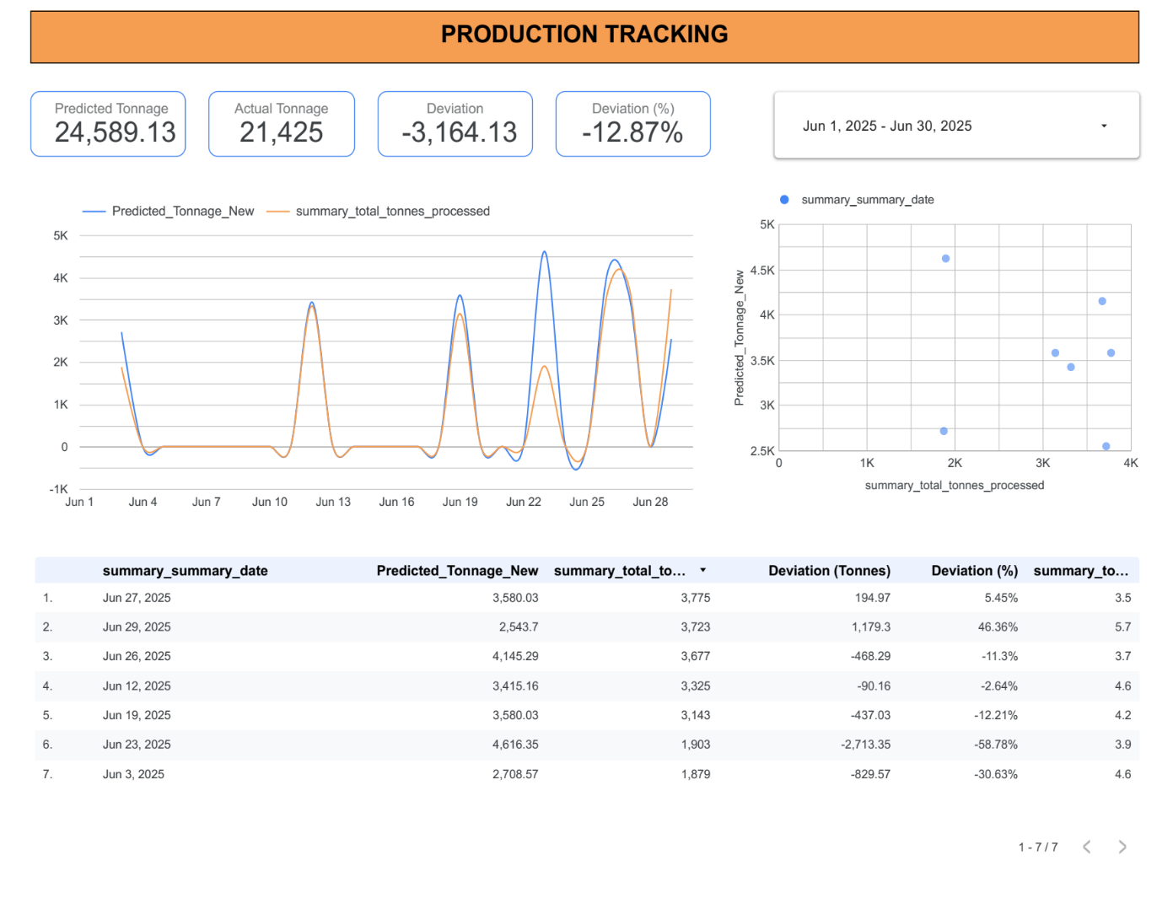

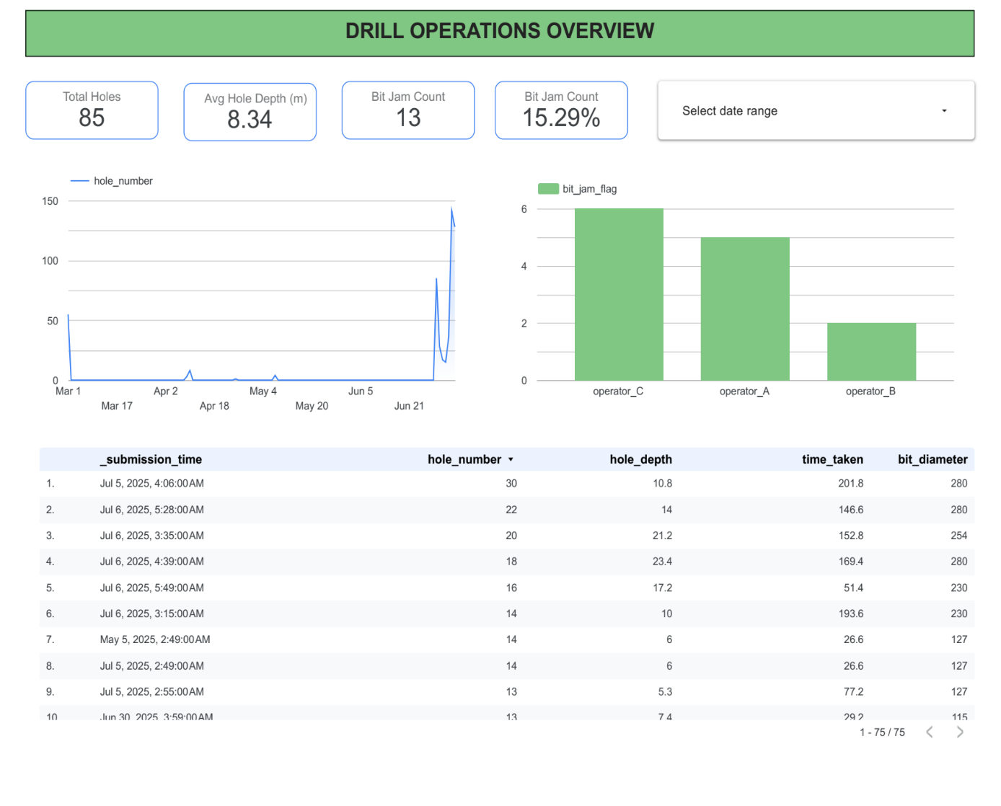





APPENDIX 2: MODEL TRAINING AND REGRESSION

Model Training Dataset

|  |  |  |  |  |
| --- | --- | --- | --- | --- |
| rolling_avg_drill_time_7d | operating_hrs_since_service | total_holes_7d | downtime_lag7 | breakdown_event |
| 68.2 | 220 | 145 | 2.1 | 0 |
| 72.1 | 310 | 128 | 0 | 0 |
| 88.5 | 450 | 165 | 1.5 | 1 |
| 65.4 | 180 | 138 | 0 | 0 |
| 91.2 | 520 | 158 | 3.2 | 1 |
| 70.3 | 250 | 142 | 0.5 | 0 |
| 85.1 | 480 | 172 | 2.8 | 1 |
| 67.8 | 190 | 135 | 0 | 0 |
| 89.6 | 490 | 168 | 2.5 | 1 |
| 66.1 | 210 | 140 | 0 | 0 |
| 74.5 | 290 | 148 | 1.1 | 0 |
| 87.2 | 470 | 170 | 3 | 1 |
| 69.1 | 230 | 139 | 0 | 0 |
| 83.4 | 440 | 162 | 2 | 1 |
| 64.9 | 170 | 132 | 0 | 0 |
| 90.1 | 510 | 175 | 3.5 | 1 |
| 71.5 | 270 | 146 | 0.8 | 0 |
| 86.3 | 460 | 167 | 2.7 | 1 |
| 68.9 | 240 | 141 | 0 | 0 |
| 84.7 | 455 | 164 | 2.4 | 1 |

Python and libraries: numpy, sklearn, matplotlib.

import numpy as np

import matplotlib.pyplot as plt

from sklearn.datasets import make_classification

from sklearn.model_selection import train_test_split

from sklearn.linear_model import LogisticRegression

from sklearn.metrics import RocCurveDisplay, auc

# classify dataset to have 4 features from the 1000 samples

X, y = make_classification(n_samples=1000, n_features=4, n_redundant=0, n_informative=4,

                           n_clusters_per_class=1, flip_y=0.1, random_state=42)

# Split the data

X_train, X_test, y_train, y_test = train_test_split(X, y, test_size=0.3, random_state=42)

# Train a logistic regression model

logistic_model = LogisticRegression()

logistic_model.fit(X_train, y_train)

y_score_logistic = logistic_model.predict_proba(X_test)[:, 1]

fpr_logistic, tpr_logistic, _ = roc_curve(y_test, y_score_logistic)

roc_auc_logistic = auc(fpr_logistic, tpr_logistic)

# Train a Boosted Trees model

gb_model = GradientBoostingClassifier()

gb_model.fit(X_train, y_train)

y_score_gb = gb_model.predict_proba(X_test)[:, 1]

fpr_gb, tpr_gb, _ = roc_curve(y_test, y_score_gb)

roc_auc_gb = auc(fpr_gb, tpr_gb)

# Plot both

plt.figure()

plt.plot(fpr_logistic, tpr_logistic, color='blue', lw=2, label='Logistic Regression (AUC = %0.2f)' % roc_auc_logistic)

plt.plot(fpr_gb, tpr_gb, color='darkorange', lw=2, label='Boosted Trees (AUC = %0.2f)' % roc_auc_gb)

plt.plot([0, 1], [0, 1], color='navy', lw=2, linestyle='--')

plt.xlim([0.0, 1.0])

plt.ylim([0.0, 1.05])

plt.xlabel('False Positive Rate')

plt.ylabel('True Positive Rate')

plt.title('Receiver Operating Characteristic (ROC) Curve')

plt.legend(loc="lower right")

plt.show()



APPENDIX 3: FORMS INPUTS AND FIELS













FIELDS

|  |  |  |
| --- | --- | --- |
| Field | Type | Choices / Validation |
| drill_info_entry_by | text | operator_A, operator_B, operator_C |
| drill_info_entry_date | date |  |
| drill_info_shift | select_one | Morning, Afternoon, Night |
| drill_info_machine_id | select_one | Rig01, Rig02, Rig03 |
| drill_info_holes_drilled | integer | 1 – 50 |
| drill_info_avg_hole_depth | decimal | 4.5 – 12.0 (m) |
| drill_info_fuel_used | decimal | 50.0 – 100.0 (litres) |
| crew_size | integer | 2 – 6 |
| hole_time_min | decimal | 20.0 – 120.0 (min) |
| holes_per_shift | integer | = drill_info_holes_drilled |
| Field | Type | Choices / Validation |
| shift_summary_entry_by | text | supervisor_A, supervisor_B, supervisor_C |
| shift_summary_entry_date | date |  |
| shift_summary_shift | select_one | Morning, Afternoon, Night |
| shift_summary_drilling_summary | text | narrative text |
| shift_summary_incident_occurred | select_one | Yes, No |
| shift_summary_performance_rating | select_one | Poor, Fair, Good, Excellent |
| shift_summary_actions_taken | text | free text |
| shift_summary_safety_observation | text | free text |
| shift_summary_next_shift_notes | text | free text |

|  |  |  |
| --- | --- | --- |
| Field | Type | Choices / Validation |
| post_blast_entry_by | text | supervisor_A, manager_B, engineer_C |
| post_blast_entry_date | date |  |
| post_blast_blast_id | text | e.g. “BL-20250615-003” |
| post_blast_volume_estimate | integer | 2 000 – 10 000 (m³) |
| post_blast_tonnage_estimate | integer | 5 000 – 20 000 (t) |
| post_blast_fragmentation_quality | select_one | Very Fine, Fine, Medium, Coarse |
| post_blast_oversize_present | select_one | Yes, No |
| post_blast_oversize_percentage | decimal | 1.0 – 15.0 % |
| post_blast_burden_m | decimal | 1.0 – 3.0 m |
| post_blast_spacing_m | decimal | 2.0 – 5.0 m |
| post_blast_bench_height_m | decimal | 5.0 – 10.0 m |
| post_blast_powder_factor | decimal | 0.3 – 1.2 kg/m³ |
| post_blast_moisture_condition | select_one | Dry, Moist, Wet |
| post_blast_misfire_count | integer | 0 – 3 |
| post_blast_safety_incident | select_one | Yes, No |

|  |  |  |
| --- | --- | --- |
| Field | Type | Choices / Validation |
| maintenance_log_entry_by | text | maint_A, maint_B, mechanic_C |
| maintenance_log_entry_date | date |  |
| maintenance_log_machine_id | select_one | Rig01, Crusher01, Excavator01, DrillRig02 |
| maintenance_log_issue_type | select_one | Breakdown, Inspection, Upgrade, Repair, Calibration |
| maintenance_log_downtime_hours | decimal | 0.5 – 8.0 hrs |
| maintenance_log_spare_delay | decimal | 0.0 – 4.0 hrs |
| maintenance_log_maintenance_type | select_one | Routine, Preventive, Corrective, Emergency |
| maintenance_log_parts_replaced | text | comma-separated list or “None” |
| maintenance_log_machine_operating_hours | decimal | 100 – 1 000 hrs |
| maintenance_log_cost_usd | decimal | 200.00 – 2 000.00 USD |
| maintenance_log_severity_rating | select_one | Low, Medium, High, Critical |
| maintenance_log_next_service_due | date |  |
| maintenance_log_bench_zone | select_one | Zone A, Zone B, Zone C, Zone D |
| maintenance_log_notes | text | free text |

|  |  |  |
| --- | --- | --- |
| Field | Type | Choices / Validation |
| blasting_info_entry_by | text | supervisor_A, blaster_B, engineer_C |
| blasting_info_entry_date | date |  |
| blasting_info_blast_id | text | e.g. “BL-20250615-012” |
| blasting_info_holes_blasted | integer | 50 – 200 |
| blasting_info_explosive_type | select_one | ANFO, Emulsion, Dynamite |
| blasting_info_initiation_method | select_one | Electronic, Non-electric, Detonating cord |
| blasting_info_stemming_length | decimal | 1.0 – 3.0 m |
| blasting_info_blast_pattern | select_one | Regular, Staggered, Square, Triangle |
| blasting_info_issues_occurred | select_one | Yes, No |
| blasting_info_explosive_qty | decimal | 500.0 – 2 000.0 kg |
| blasting_info_bench_zone | select_one | Zone A, Zone B, Zone C, Zone D |
| blasting_info_weather | select_one | Clear, Rain, Overcast, Windy |

CENTRAL DATABASE

